POSITIVE PARTNERSHIPS · PROFESSIONAL LEARNING
Facilitator Guide
Secondary Education Online
SESSION  1 | SESSION  2 | SESSION  3 | SESSION  4

One page for every slide. Each page shows the slide, what it is for, what to do and say, the activity and how long to spend.
Four online sessions of 60 minutes · Timings are indicative

How to use this guide
The guide follows the four online slide decks exactly. Every visible slide has its own page, in deck order, so you can keep the guide open beside the presenter view and turn one page per slide.
Each session opens with a planning page: the intent, what participants will leave with, what to prepare, and a run sheet. Times are minutes into the 60-minute session. A producer cue page follows, listing each activity, how it runs and what to paste in the chat.
EVERY SLIDE PAGE HAS
Header strip | The session colour, the session name and the slide number in the deck.
Slide and facts | A picture of the slide, the suggested minutes, the minutes into the session, the grouping, and the Participant Guide page if there is one.
Purpose | One line on why the slide is there.
What to do | Numbered steps, in order.
Key messages | What participants should take from the slide.
You might say | Wording you can use or adapt, where the team has written it.
Activity card | Format, grouping, time, the prompt, steps, how to bring the room back and how to close.
Keep in mind | Cautions and what to avoid.
Background and thread | Context for you, and how the slide links to other sessions.

SESSION COLOURS
Each session keeps the colour used in the Participant Guide, so the page a participant has open matches the colour on your page.

The series at a glance
Length | Session |  | Slides | Page
60 minutes | 1 | Autism, Sensory and Ways of Thinking | 18 slides | p. 6
60 minutes | 2 | Communication, Connection and Daily Capacity | 18 slides | p. 26
60 minutes | 3 | Designing for Access Across Secondary School | 17 slides | p. 46
60 minutes | 4 | Working in Partnership with Students and Families | 17 slides | p. 65

The thread through the series
Participants hold two or three real, different students in mind from Online Session 1 onwards. The sessions run on separate days, so each one opens by reconnecting with the last. Several Participant Guide pages carry forward:
- Online Session 1: Think about your students and the routine review, plus a noticing task before Session 2.
- Online Session 2: the school-day map and the Carry into design card (brought to Session 3).
- Online Session 3: the brief, the design and the private My students check.
- Online Session 4: Bridge to the next family conversation, Start · Continue · Reconsider, the conversation plan and the final reflection back to Session 1.

Ways of working
- Cameras are optional. Chat, reactions, speaking, private notes or passing all count as taking part.
- Invite contributions; never cold-call. Put every activity prompt in the chat before breakout rooms open.
- Keep the students participants have in mind anonymous. Initials or roles only, in the chat and in breakout rooms.
- Breakout rooms are pairs or trios. Anyone can ask to stay in the main room, with a main-room option for each activity.
- Work with a producer or co-host who admits participants, opens breakout rooms, and pastes prompts and links into the chat.
- Look at the environment, task and routine before asking a student to change. Include strengths, interests and joy.
- Participants write in their Participant Guide (digital or printed).

Before each session
☐ Deck open in presenter view, with videos tested with shared sound and captions.
☐ Producer or co-host confirmed, with the prompts and links for this session ready to paste into the chat.
☐ Participant Guide link sent to participants, with a note to have it open or printed.
☐ Breakout rooms planned (pairs or trios) and the main-room option agreed.
☐ The session Prepare list checked. Each session opens with its own list, on its planning page.

Running it online
Roles
- Facilitator: leads the content and the room, and keeps an eye on time.
- Producer or co-host: admits people, runs breakout rooms, pastes prompts and links into the chat, watches the chat, and helps anyone with technical problems by private message.
- Agree before each session who takes over if the facilitator loses connection. The producer keeps the room going (for example by starting the next discussion in the chat) until the facilitator is back.

Zoom settings
- Turn on automatic captions (live transcription) at the start of each session and tell participants how to show them.
- Breakout rooms: allow participants to return to the main room, set a 60-second countdown, and assign manually or automatically as suits the group. Keep a note of anyone who asked to stay in the main room.
- Share sound when playing videos. Have the video link ready to paste in the chat in case playback stutters.
- Whiteboard and annotation: check they are enabled for participants before the session that uses them.

Recording
- Decide before the series whether the main room is recorded, and tell participants at the start of each session.
- Never record breakout rooms. Remind people to use initials or roles only when talking about students.

If something goes wrong
- A video will not play: paste the link in the chat, give people 2 or 3 minutes to watch, and move on to the discussion.
- Breakout rooms fail or people get lost: run the activity in the main room, with chat responses.
- Someone is distressed: the producer checks in by private message, and the facilitator follows up after the session.
- Running behind: each session names one or two places to shorten, on its first slide page.

SESSION  1 | ONLINE · 60 MINUTES · 18 SLIDES  Autism, Sensory and Ways of Thinking

SESSION INTENT
Welcome participants to the online series, centre student voice and establish a neurodiversity-affirming, environment-first lens. Participants bring two or three different students to mind and build a concise set of sensory, thinking and capacity concepts they can use to ask better questions about one familiar secondary school routine, task or transition.
PARTICIPANTS LEAVE WITH
- Hold two or three different students in mind as a reference point for the series.
- Describe a neurodiversity-affirming, environment-first lens and the idea of dynamic disability.
- Name the eight senses, sensory joy and stimming, detail-first processing, deep focus and executive functioning as lenses for inquiry.
- Look at the sensory and task demands of one familiar secondary routine before the student's response.

RUN SHEET
Minutes in | Segment | Slides | Minutes
0 - 7 | Welcome, acknowledgements and taking part online | 1-4 | 7
7 - 22 | Students in mind and student voice | 5-7 | 15
22 - 32 | The lens: affirming stance, social model, dynamic disability | 8-10 | 10
32 - 37 | Sensory processing | 11-12 | 5
37 - 47 | Autistic thinking and internal signals | 13-16 | 10
47 - 58 | Secondary routine or transition review activity | 17 | 11
58 - 60 | Before the next session and close | 18 | 2

PREPARE
☐ Traditional Custodians confirmed for where you are presenting from, and Acknowledgement of Country prepared in your own words.
☐ Student voice video tested through screen share with sound and captions on; transcript link ready.
☐ Chat and reactions enabled; breakout rooms set for 2 or 3 per room.
☐ Producer or co-host briefed: admitting late joiners, pasting prompts and links, opening breakouts.
☐ Activity prompt and between-session prompts ready to paste into the chat, with secondary examples (lessons, corridors, specialist rooms, handovers).
☐ Participant Guide sent in advance so people have a digital or printed copy.
☐ Visible timer and a main-room alternative ready for the activity.

Producer cues · Session 1
For the producer or co-host. At the start: admit participants, turn on captions, and paste the Participant Guide link and the session title in the chat. For each activity: paste the prompt before rooms open, broadcast a one-minute warning, and close rooms on time.
Slide | Activity | How | Time | Paste in the chat
5 | Think about your students | on your own | 3 minutes | What are you here for? What would you like to understand better? What strengths, interests or moments of connection should stay visible?
7 | What did you notice? | on your own, then the chat | 4 minutes | What did you notice? What stayed with you? What would you like to understand more deeply?
17 | Sensory activity | breakout rooms of 2 or 3, with a main-room option | 11 minutes (1 minute to choose, about 6 in breakouts plus a minute for rooms to open and close, 3 to debrief) | Choose one familiar routine in a class or across the school day. What sensory demands does the environment or task create, and what options could increase access or choice?

SESSION 1 | Autism, Sensory and Ways of Thinking | SLIDE 1 of 18

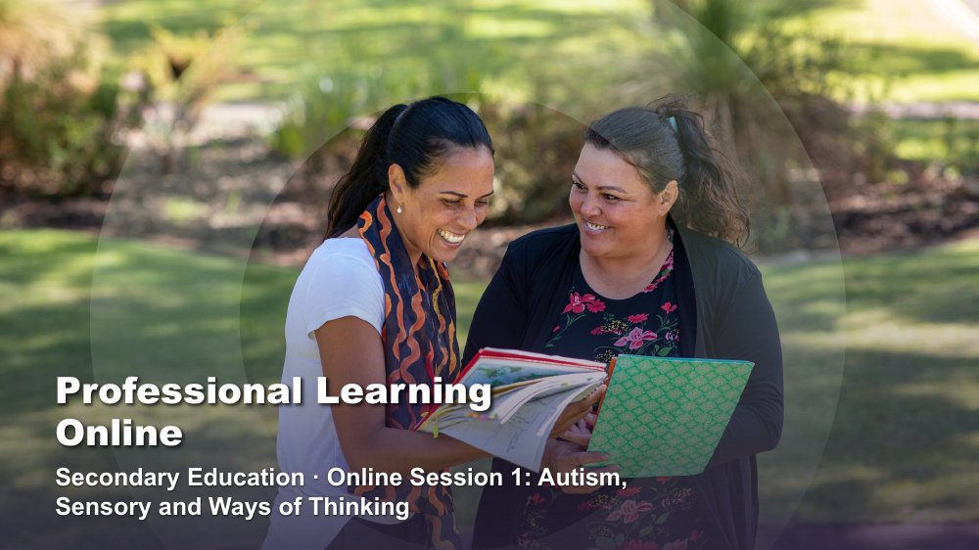 | Professional Learning Online - Secondary Education  SUGGESTED TIME  1 min  MINUTES INTO SESSION  0 - 1

Open the online series with the shared starting point: how educators understand students and school.
WHAT TO DO  - Have the title slide shared as participants join; the producer can paste a short welcome in the chat.  - Welcome participants and introduce the delivery team, including the producer or co-host.  - Name this as professional learning about understanding Autistic experience and improving access, belonging and partnership.  - Frame the series around curiosity and support, not fixing students or making them appear less Autistic.  - Keep this opening brief so the student reflection and student voice keep their time. | KEY MESSAGES  - The series begins with the lens educators bring to students and school.  - Curiosity will connect the four online sessions.

KEEP IN MIND
- Late joiners are common online. The producer can admit them and paste the welcome again without the facilitator stopping.
- Flex points if running behind: on slide 7, read out two chat responses and move on; on slide 12, walk the four points without the chat invitation; on slide 15, name the ten areas without discussing each one. Protect the sensory activity on slide 17.

SESSION 1 | Autism, Sensory and Ways of Thinking | SLIDE 2 of 18

 | Acknowledgement of Country  SUGGESTED TIME  2 min  MINUTES INTO SESSION  1 - 3

Acknowledge the Traditional Custodians of the land on which the session is taking place, including the many Countries participants are joining from.
WHAT TO DO
- Deliver the Acknowledgement of Country in your own words, following organisational protocol.
- Name the Traditional Custodians of the land you are presenting from, where this has been confirmed.
- Acknowledge that participants are joining from many Countries, and invite them to name the Country they are on in the chat if they wish.
- Allow a brief pause before moving on.

KEEP IN MIND
- Do not read a generic script you have not prepared; take time before the session to learn the Country and custodians where you are presenting from.
- Keep the Acknowledgement respectful and unhurried, even if the session is running late.

SESSION 1 | Autism, Sensory and Ways of Thinking | SLIDE 3 of 18

 | First Nations advisory  SUGGESTED TIME  1 min  MINUTES INTO SESSION  3 - 4

Advise First Nations participants that the session may contain images and voices of people who are no longer with us.
WHAT TO DO
- Read the advisory aloud, for anyone listening without video, and leave it on screen long enough for everyone to read it.
- Move on without further comment.

SESSION 1 | Autism, Sensory and Ways of Thinking | SLIDE 4 of 18

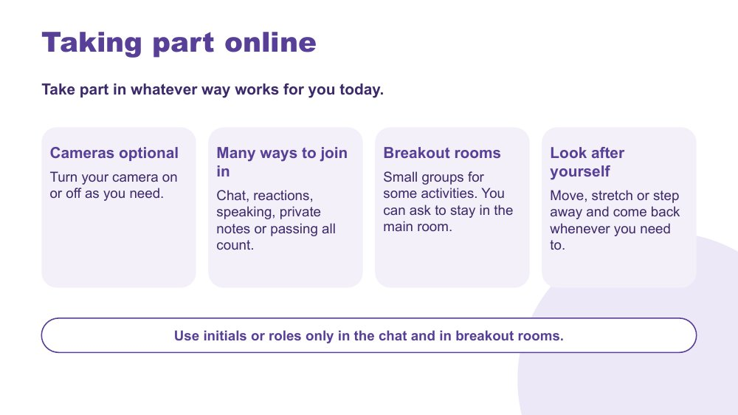 | Taking part online  SUGGESTED TIME  3 min  MINUTES INTO SESSION  4 - 7

Agree how people can take part online so every way of joining in counts, and set privacy expectations for the series.
WHAT TO DO  - Walk through the four points on the slide.  - Say that cameras are optional and people can turn them on or off as they need through the session.  - Name the ways to join in: chat, reactions, speaking, private notes or passing. All of them count.  - Explain that some activities use breakout rooms, and anyone can ask the producer to stay in the main room instead.  - Invite people to move, stretch or step away and come back whenever they need to.  - Ask everyone to use initials or roles only in the chat and in breakout rooms.  - Invite a quick first response: a reaction, or one word in the chat about what they are hoping for today. Passing is fine. | KEY MESSAGES  - Different ways of taking part online are welcome.  - Initials or roles only protects students and families.  - People can look after themselves at any point.

YOU MIGHT SAY
There is no single right way to take part today. Some people think best with their camera off, some by typing, some by listening. All of it counts.
When we talk about students, please use initials or a role, like 'a Year 9 student', rather than names.

KEEP IN MIND
- Do not cold-call. Invite, and let people choose how to respond.
- Breakout rooms are not recorded. If the main room is recorded, say so now and say what is captured.

Background The same things participants will be asked to offer students (choice, more than one way to communicate, permission to step away) are modelled here in how the session runs.
RESOURCES
- Zoom chat and reactions

SESSION 1 | Autism, Sensory and Ways of Thinking | SLIDE 5 of 18

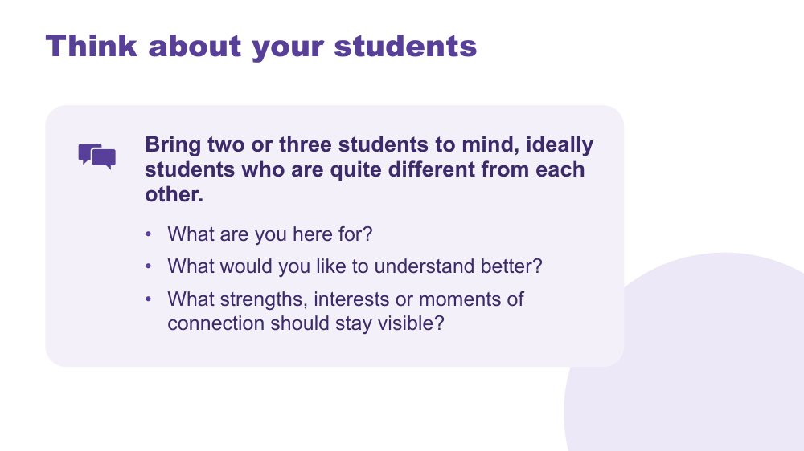 | Think about your students  SUGGESTED TIME  4 min  MINUTES INTO SESSION  7 - 11  GROUPING  On your own  PARTICIPANT GUIDE  Participant Guide - Think about your students

Give every participant a student-centred point of reference for the series.
WHAT TO DO  - Invite participants to bring two or three students to mind, ideally students who are quite different from each other.  - Suggest they might differ in year level, subjects, communication or what school feels like for them.  - Ask participants to write in their Participant Guide or private notes, using initials or roles only. Not in the chat.  - Use the questions on screen to support private reflection.  - Give quiet thinking time; cameras can go off if that helps people think.  - If anyone shares, redirect descriptions away from labels and towards what they want to understand.  - Ask participants to return to the same students in each online session. | KEY MESSAGES  - See each student as a whole person, with strengths and interests as well as needs.  - Holding several different students builds a broad, mixed picture of Autistic experience.  - Questions can remain open while participants gather a fuller picture.

ACTIVITY | Private reflection on your own · 3 minutes
What are you here for? What would you like to understand better? What strengths, interests or moments of connection should stay visible?
- Ask participants to write without using students' names or school.
- Invite them to include strengths, interests or moments of connection as well as questions.
- Keep sharing optional; this reflection stays private.
Close: Ask participants to keep the reflection handy for the rest of the series.

Thread The students brought to mind here return in the school-day mapping (Online Session 2), classroom design (Online Session 3) and final reflection (Online Session 4).

SESSION 1 | Autism, Sensory and Ways of Thinking | SLIDE 6 of 18

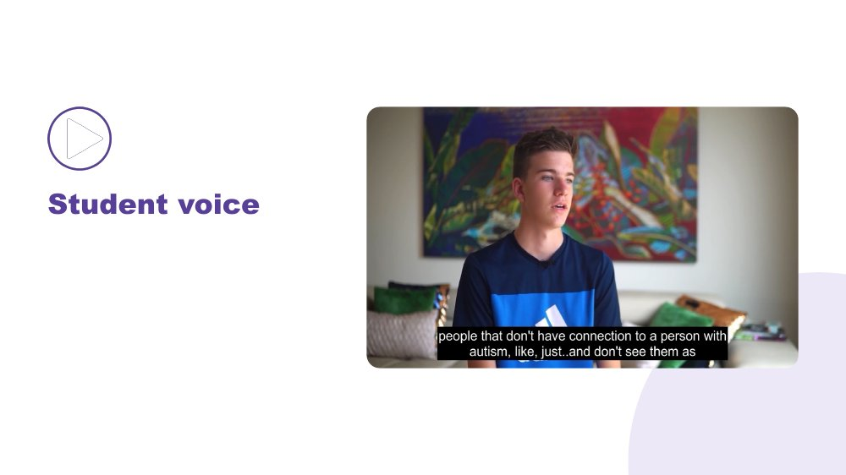 | Student voice  SUGGESTED TIME  6 min  MINUTES INTO SESSION  11 - 17

Make space for Autistic young people to be heard in their own words.
WHAT TO DO  - Introduce the video as an opportunity to listen rather than diagnose, compare or extract a single lesson.  - Share the video through Zoom screen share with computer sound on, and captions on.  - Producer pastes the transcript link in the chat.  - Play the video without interrupting. | KEY MESSAGES  - Student voice is part of the evidence in this series.  - Each speaker's account is their own.

KEEP IN MIND
- Test sound and playback through screen share before the session. If it stutters, have the producer share it, or paste a link so people can watch on their own device.

SESSION 1 | Autism, Sensory and Ways of Thinking | SLIDE 7 of 18

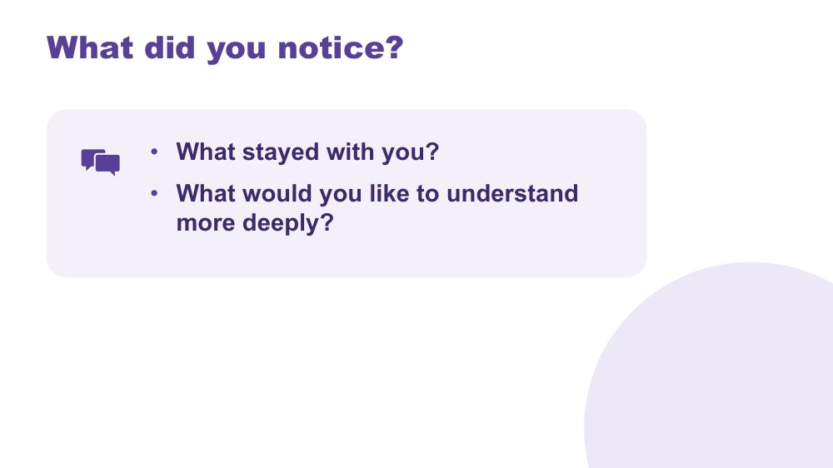 | What did you notice?  SUGGESTED TIME  5 min  MINUTES INTO SESSION  17 - 22  GROUPING  On your own, then the chat  PARTICIPANT GUIDE  Participant Guide - What did you notice?

Support reflection on the student voice material.
WHAT TO DO
- Invite brief private reflection on the questions before anyone responds.
- Invite observations grounded in what speakers said rather than interpretations of appearance or behaviour.
- Avoid asking participants to compare a speaker with a student they teach.
- Read out a few recurring words or questions from the chat without forcing consensus.
- Note questions that need follow-up through the appropriate program or local channel.

ACTIVITY | Think, write and optional share on your own, then the chat · 4 minutes
What did you notice? What stayed with you? What would you like to understand more deeply?
- Give a minute of quiet writing time.
- Invite one word or short phrase in the chat, or a spoken contribution. Passing is fine.
- Read out a few recurring words or questions so everyone can hear them.
Close: Link participants' questions to the sensory and thinking content that follows, and to communication and the school day in Online Session 2.

SESSION 1 | Autism, Sensory and Ways of Thinking | SLIDE 8 of 18

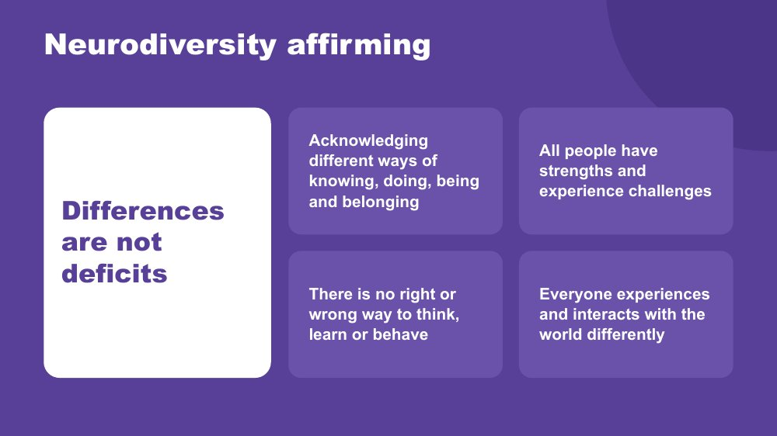 | Neurodiversity affirming  SUGGESTED TIME  4 min  MINUTES INTO SESSION  22 - 26

Establish the practical, strengths-based stance participants will use throughout the series.
WHAT TO DO  - Walk through the principles on the slide.  - Connect the principles to the students participants brought to mind earlier.  - Ask what becomes visible when strengths, interests, joy and ways of connecting are included. Invite a response in the chat or aloud.  - Clarify that a strengths-based approach does not erase difficulty, access needs or fluctuating capacity.  - Model language that describes the environment and support needed without blaming the student. | KEY MESSAGES  - Begin with the person.  - Include strengths and joy alongside barriers and support needs.  - Stay curious about access and support.

SESSION 1 | Autism, Sensory and Ways of Thinking | SLIDE 9 of 18

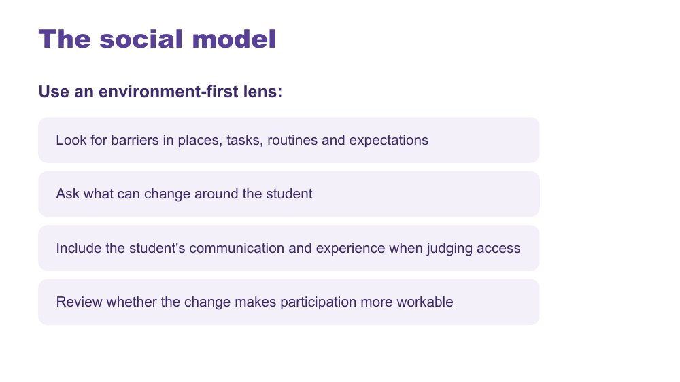 | The social model  SUGGESTED TIME  3 min  MINUTES INTO SESSION  26 - 29

Connect the series lens with an environment-first view of barriers.
WHAT TO DO  - Explain the social model through barriers in places, tasks, routines and expectations.  - Walk through the environment-first steps on the slide.  - Use one brief secondary example, such as a crowded corridor between periods, and ask what could change around the student.  - Emphasise including the student's communication and experience when judging access. | KEY MESSAGES  - Look for barriers before asking the student to change.  - Environment and support are part of the experience being examined.

KEEP IN MIND
- Avoid implying that all difficulty disappears when an environment changes.

SESSION 1 | Autism, Sensory and Ways of Thinking | SLIDE 10 of 18

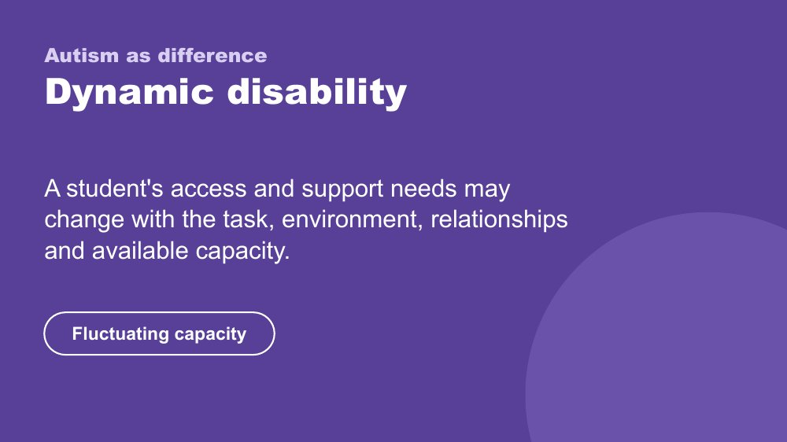 | Autism as difference - dynamic disability  SUGGESTED TIME  3 min  MINUTES INTO SESSION  29 - 32

Introduce the framing of autism as difference and dynamic disability.
WHAT TO DO  - Explain how access and support needs can vary with the task, environment, relationships and available capacity.  - Name fluctuating capacity: what a student can do one day or in one setting may not be available in another. In secondary, this can shift across periods, subjects and teachers in a single day.  - Connect the concept back to the need for curiosity across settings and days. | KEY MESSAGES  - Support should respond to the student and context rather than a fixed assumption.  - Strengths and substantial support needs can both belong in the picture.

KEEP IN MIND
- Avoid presenting one pattern of ability, need or capacity as universal.
- Do not add clinical, diagnostic or legal claims.

SESSION 1 | Autism, Sensory and Ways of Thinking | SLIDE 11 of 18

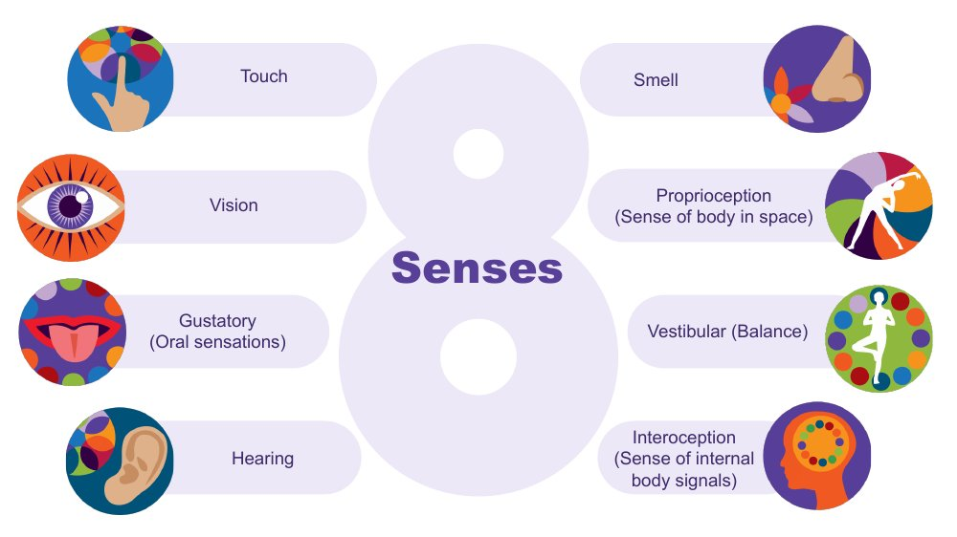 | The eight senses  SUGGESTED TIME  3 min  MINUTES INTO SESSION  32 - 35

Extend the familiar five senses to eight and introduce interoception to return to later.
WHAT TO DO  - Start from the five senses many of us were taught: touch, vision, taste, hearing and smell.  - Ask participants to name the three less well known senses in the chat or aloud. Give time to respond.  - Name them: proprioception, vestibular and interoception.  - Describe proprioception and vestibular with a school example for each.  - Name interoception and park it: say you will come back to it later in this session.  - Connect the senses to classrooms, specialist spaces, corridors and breaks. | KEY MESSAGES  - There are 8 senses, not 5.  - The hidden three are often where Autistic differences are most significant.  - Interoception is flagged here and picked up again at the end of this session.

YOU MIGHT SAY
Proprioception is the sense of where the body is in space. Students who crash into things, seek heavy pressure, or need to feel their body may be seeking proprioceptive input.
Vestibular is balance and movement. A student who needs to rock, spin, or keep moving in class may be regulating through this sense.
Interoception is the body's inside sense - and it is one of the most important for understanding a student's experience at school. Park it for now.
We will come back to interoception before the end of this session. It connects to a lot of what follows.

Background Touch (tactile) gives information about texture, pain, pressure and temperature. Vision gives depth, colour, size, shape and position. The gustatory sense includes taste and other oral sensations such as texture, temperature and how much pressure is needed when chewing. Hearing (auditory) tells us how far away, how loud and how familiar a sound is, and its pitch. Smell (olfactory) can link strongly to emotional memory. Proprioception comes through joints, muscles, ligaments and deep in the skin; differences may mean bumping into things. The vestibular sense sits in the middle ear, tracks speed and direction of head movement and supports balance; a student may love spinning, or may feel off balance on stairs. There is lots of crossover between the senses: in any situation we use all or most of them.
Thread Interoception returns in the internal signals slide (slide 16) later in this session.
RESOURCES
- Interoception webinar recording and resources on the Positive Partnerships website

SESSION 1 | Autism, Sensory and Ways of Thinking | SLIDE 12 of 18

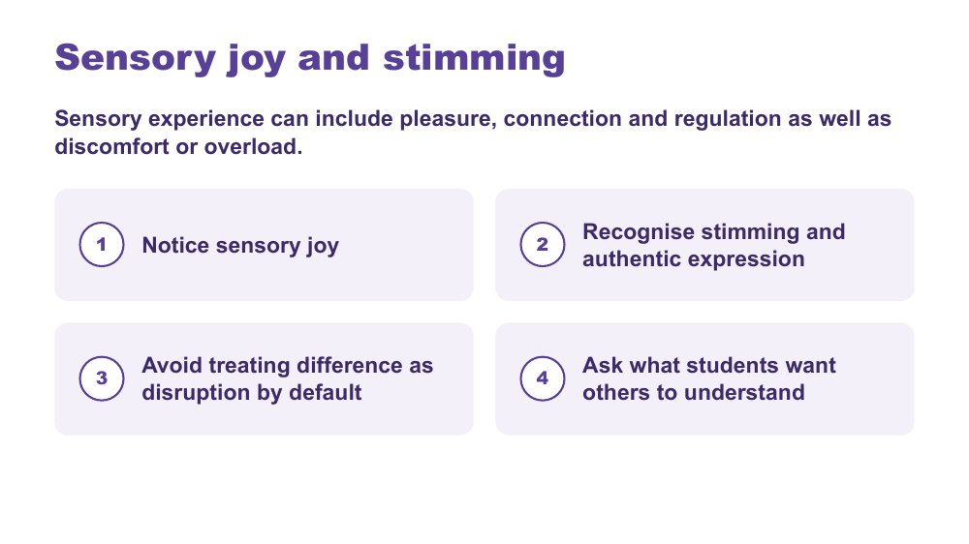 | Sensory joy and stimming  SUGGESTED TIME  2 min  MINUTES INTO SESSION  35 - 37

Recognise sensory joy, stimming and authentic expression as part of sensory experience.
WHAT TO DO  - Read the framing line: sensory experience can include pleasure, connection and regulation as well as discomfort or overload.  - Walk through the four points on the slide.  - Ask participants where they see sensory joy in the students they have in mind. They can note it privately or add a word to the chat. | KEY MESSAGES  - Sensory inquiry should include joy and authentic expression as well as discomfort or overload.  - Stimming can be pleasure, connection, regulation and authentic expression.  - Ask what students want others to understand.

KEEP IN MIND
- Do not discourage harmless stimming.
- Do not frame typical-looking behaviour as the goal.
- Avoid treating difference as disruption by default.

SESSION 1 | Autism, Sensory and Ways of Thinking | SLIDE 13 of 18

 | The Detail-First Brain  SUGGESTED TIME  3 min  MINUTES INTO SESSION  37 - 40  PARTICIPANT GUIDE  Participant Guide - Strengths I can see

Introduce bottom-up, detail-first processing and the strengths it produces.
WHAT TO DO  - Open with the contrast between filtering first and taking in what is actually there.  - Name this as bottom-up processing.  - Connect it to sensory intensity, literal language, pattern recognition and deep focus.  - Move through the strengths slowly: pattern recognition, systems thinking, deep memory, logical precision, honesty and directness, depth of connection, intense engagement.  - Invite a few chat responses connecting a strength to the students they have in mind, rather than working through every strength aloud.  - Invite participants to note strengths for Student A, B and C in the Participant Guide - Strengths I can see. | KEY MESSAGES  - Autistic cognition builds from detail up - bottom-up processing.  - This connects to sensory intensity, literal language, and everything that follows.  - The strengths listed are genuine features, not compensations.  - Educators who leave with vocabulary for these strengths will notice and build on them in the classroom.

YOU MIGHT SAY
Most brains filter first - they predict what is there based on expectation and fill in the rest. The detail-first brain does not filter first. It takes in what is actually there. Then it builds the whole picture from those pieces upward. That is bottom-up processing.
This is the architecture that connects sensory intensity, literal language, pattern recognition, and deep focus. They are not a list of separate Autistic traits. They are features of the same way of taking in the world.
Pattern recognition - where do you see this in your subject, and in which student?
Deep memory - what does one of them know by heart? Does it look different in another?
Honesty and directness - how does this show up at school?
These are not future potential. They are present now.

KEEP IN MIND
- Some educators may be used to a deficit or "despite" lens ("despite X they can Y"), a consolation prize approach. These are genuine features of how this brain works.
- Avoid turning the content into a deficit list.

Background Some research suggests stronger bottom-up signalling in Autistic brains, with less dominant top-down filtering. The environment is registered more fully, more specifically and less pre-organised before reaching conscious awareness. This produces precision and depth. It also produces load: the same fuller intake that supports pattern recognition can also lead to sensory overload. A student may pick up a tiny change in routine, a background sound, or an inconsistency in what someone said. They are not being pedantic. They are seeing accurately. The educator who names a student's pattern recognition as a strength is doing something meaningful for that student's identity and sense of self, and for how peers see them.

SESSION 1 | Autism, Sensory and Ways of Thinking | SLIDE 14 of 18

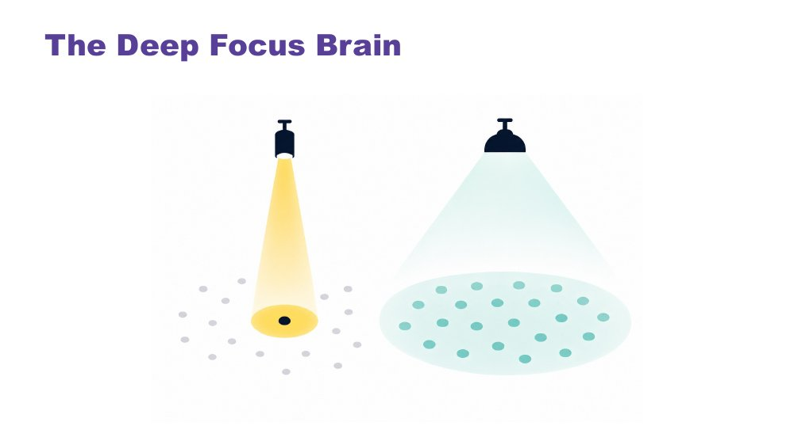 | The Deep Focus Brain  SUGGESTED TIME  3 min  MINUTES INTO SESSION  40 - 43

Introduce monotropism: deep focus, deep interests, transitions and flow.
WHAT TO DO  - Open with a question: do your thoughts travel across many topics, or go deep on one? Invite a reaction or a word in the chat.  - Give a moment to reflect.  - Move to the definition, using the visual on the slide.  - Name the key ideas: deep interests, transitions, flow.  - Use the bell example to show the cost of switching between periods. | KEY MESSAGES  - Monotropism: deep focus on fewer things at a time, not distraction or obsession.  - Deep interests are the brain's most reliable route to learning, memory, and genuine engagement.  - Transitions have a real neurological cost - the attention is genuinely invested.  - Flow is the positive expression of this architecture - the brain at its best.  - Developed and extended with Autistic people.

YOU MIGHT SAY
Torch and floodlight: the non-Autistic brain tends to spread attention across many things at once, like a floodlight. The Autistic brain tends to channel it fully into one thing at a time, like a torch beam. Neither is wrong. They illuminate different things.
Tendril theory: the tendrils extend into whatever the mind is focused on. Switching means retracting all of them. That takes time and costs something.
River: the branching river spreads across many channels - broad, covering ground, but shallower in each stream. The single deep river goes all the way in one direction. Neither is wrong. The Autistic thinking brain tends to be the deep river, not scattered, not unfocused, going somewhere completely.
Deep interests are not obsessions or fixations. They are the brain's most natural access to learning, memory, and joy.
Transitions are hard not because the student is being difficult - but because the attention is genuinely, neurologically invested. The river does not change course quickly. With warning and scaffolding this becomes more manageable. The cost is always real.
Flow - full absorption, time disappearing - is this brain at its most powerful. It is worth protecting.
Asking a student absorbed in a coding task, a design project, a piece of writing or research on a topic they love to stop and pack up when the bell goes is not a simple request. Their attention is fully in that task.

KEEP IN MIND
- Many educators will recognise this in themselves. That is fine to acknowledge, but keep the focus on the students.

Background Monotropism was developed as a framework by Dinah Murray, Mike Lesser and Wenn Lawson, and has been extended by Autistic community voices. It proposes that the core feature of Autistic attention is channelling into fewer things with greater depth, rather than distributing broadly. This explains deep interests, transition difficulty and the experience of flow.
Thread This connects directly to the detail-first brain: the same processing style, one explaining how the world arrives, one explaining where attention goes once it has.
RESOURCES
- Tendril theory comic - https://eisforerin.com/2015/08/10/tendril-theory/

SESSION 1 | Autism, Sensory and Ways of Thinking | SLIDE 15 of 18

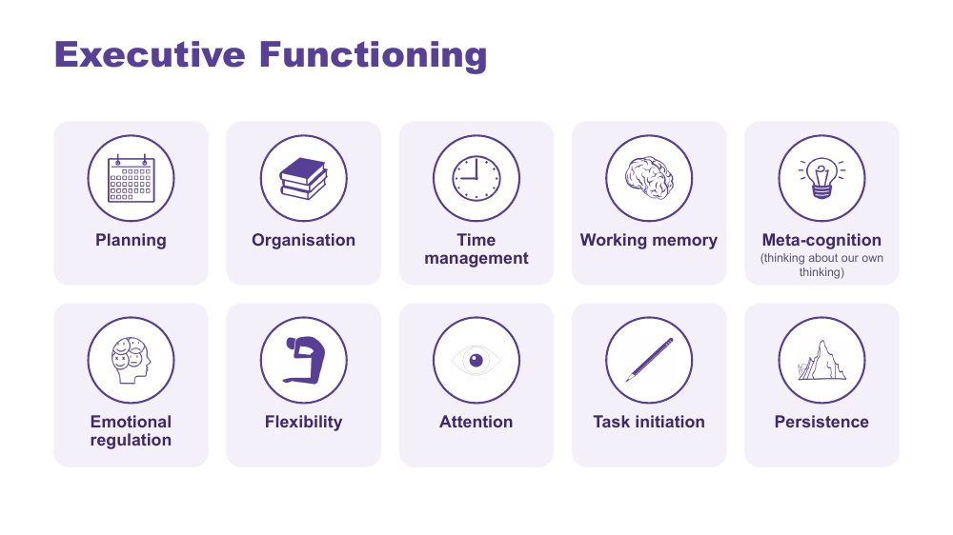 | Executive Functioning  SUGGESTED TIME  2 min  MINUTES INTO SESSION  43 - 45

Name the ten areas of executive functioning and link each to the demands of a school day.
WHAT TO DO  - Name the ten areas on the slide.  - Ask what a task asks the student to plan, start, remember, sequence, organise, switch and complete.  - Ask participants to think where each area shows up across a secondary timetable, with changes of subject, room and teacher, for the students they have in mind. | KEY MESSAGES  - The terms are lenses for inquiry, not a checklist.  - Task design, timing and support can affect access.  - Explain each term before applying it.

YOU MIGHT SAY
Useful support responds to the specific demand rather than assuming a lack of effort or motivation. Different demands may need different kinds of support.

KEEP IN MIND
- Consider how instructions, interruptions, switching, starting, sequencing and task completion are organised in the setting, without claiming a single cause.
- Keep the focus on matching support to the individual student and context.

SESSION 1 | Autism, Sensory and Ways of Thinking | SLIDE 16 of 18

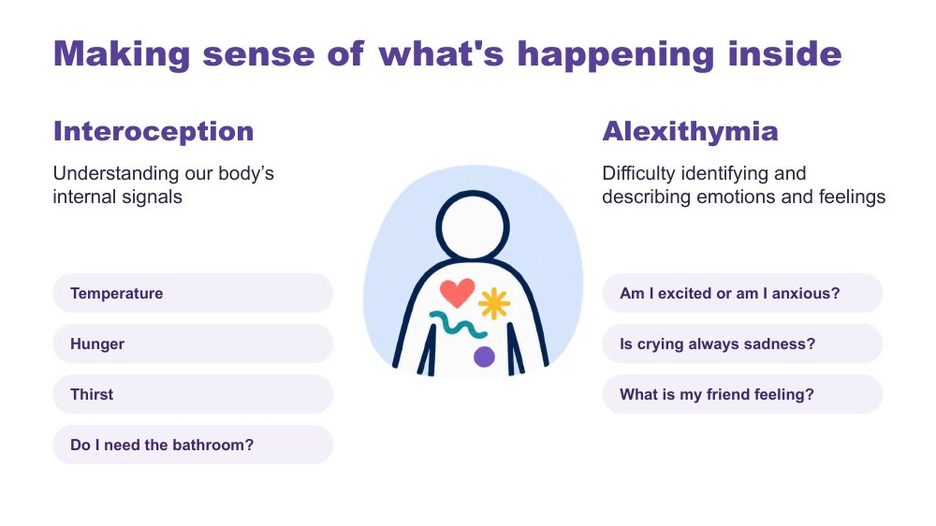 | Making sense of what's happening inside  SUGGESTED TIME  2 min  MINUTES INTO SESSION  45 - 47

Introduce interoception and alexithymia using the examples on the slide.
WHAT TO DO  - Introduce interoception: understanding our body's internal signals (temperature, hunger, thirst, needing the bathroom).  - Introduce alexithymia: difficulty identifying and describing emotions and feelings.  - Use the slide's questions as examples: Am I excited or am I anxious? Is crying always sadness? What is my friend feeling? | KEY MESSAGES  - Interoception helps answer the question "how am I doing?"  - Internal experience may not be visible to an observer.

KEEP IN MIND
- Name interoception and alexithymia without improvising definitions.
- Do not assume a student's internal state from outward behaviour.

Background Interoception is needed for knowing when to go to the toilet; knowing when you are tired, hungry or thirsty; knowing if you are hot or cold; being aware that you are becoming angry or upset. It plays a part in being able to self-regulate.
Thread Picks up the interoception seed planted on slide 11.

SESSION 1 | Autism, Sensory and Ways of Thinking | SLIDE 17 of 18

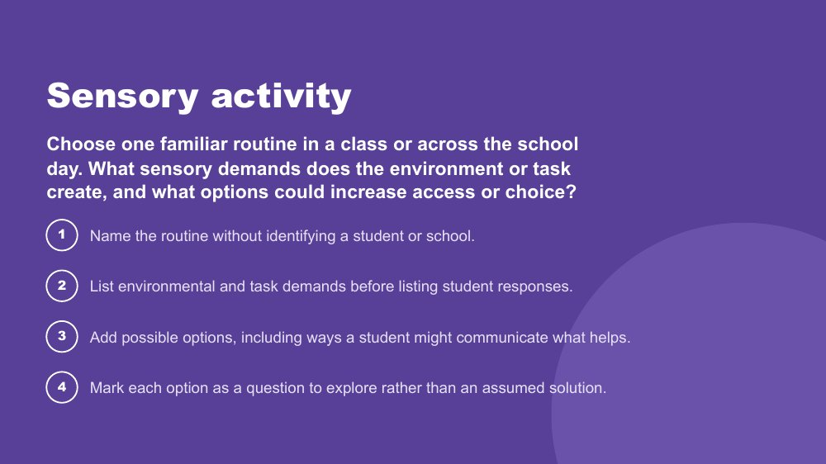 | Sensory activity  SUGGESTED TIME  11 min  MINUTES INTO SESSION  47 - 58  GROUPING  Breakout rooms of 2 or 3, with a main-room option  PARTICIPANT GUIDE  Participant Guide - Sensory activity

Apply an environment-first sensory lens to a familiar classroom routine, without simulating Autistic experience.
WHAT TO DO  - Producer pastes the prompt and the four steps into the chat before breakouts open.  - Read the prompt on the slide. Give examples of routines if needed, such as moving between periods, a practical science lesson, PE change rooms or an assembly.  - Give one minute for each person to choose a routine privately.  - Open breakout rooms of two or three for about 6 minutes, plus a minute for rooms to open and close. Anyone who prefers can stay in the main room and work on their own or with a facilitator.  - Ask participants to identify options and choice rather than one support for every student.  - Broadcast a one-minute warning before rooms close.  - Back in the main room, take one or two shares from the chat or aloud. Do not ask every room to report. | KEY MESSAGES  - Look at environmental and task demands before student responses.  - Options are questions to explore, not assumed solutions.  - One grounded question or change is enough for this activity.

ACTIVITY | Environment-first sensory review breakout rooms of 2 or 3, with a main-room option · 11 minutes (1 minute to choose, about 6 in breakouts plus a minute for rooms to open and close, 3 to debrief)
Choose one familiar routine in a class or across the school day. What sensory demands does the environment or task create, and what options could increase access or choice?
- Name the routine without identifying a student or school.
- List environmental and task demands before listing student responses.
- Add possible options, including ways a student might communicate what helps.
- Mark each option as a question to explore rather than an assumed solution.
Bring the room back
- What could educators change, offer or investigate before increasing demands on the student?
Close: Ask what educators can change, offer or investigate before increasing demands on the student, and link this to the noticing task on the next slide.

KEEP IN MIND
- Do not run an autism simulation.
- Keep students and schools unidentifiable.
- Treat lighting, sound, movement, proximity, transitions and materials as participant-generated examples, not universal triggers.
- Initials or roles only in breakout rooms, and do not record them.

Background Main-room alternative: if breakouts are not possible, give five minutes of private writing using the four steps, then invite examples in the chat and group them under demands, options and questions.
RESOURCES
- Breakout rooms set to 2 or 3 per room
- Visible timer

SESSION 1 | Autism, Sensory and Ways of Thinking | SLIDE 18 of 18

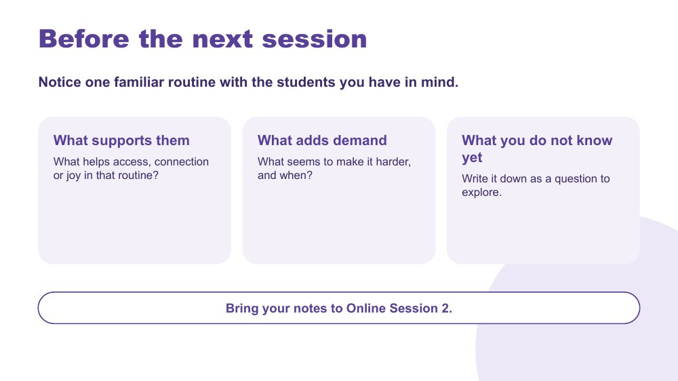 | Before the next session  SUGGESTED TIME  2 min  MINUTES INTO SESSION  58 - 60  PARTICIPANT GUIDE  Participant Guide - Before the next session

Close with a manageable noticing task that prepares participants for the school-day mapping in Online Session 2.
WHAT TO DO  - Walk through the three prompts on the slide: what supports them, what adds demand, what you do not know yet.  - Ask participants to notice one familiar routine they are already part of, with the students they have in mind.  - Explain that the task is optional and should not involve collecting identifiable information. Initials or roles only.  - Producer pastes the three prompts into the chat so people can copy them.  - Ask people to bring their notes to Online Session 2, and say that anyone who could not do it can still take part fully.  - Preview that Online Session 2 explores communication, connection and how demands build across a secondary school day, across subjects and teachers.  - Thank participants and give the next session date and joining details. | KEY MESSAGES  - Curiosity continues between sessions.  - Notice what supports access, connection and joy, not only what adds demand.  - What you do not know yet is worth writing down as a question.

YOU MIGHT SAY
You do not need to do anything extra with the students. Just notice one routine you are already part of, and write down what you see.

KEEP IN MIND
- Keep the task light. Some participants will not have a chance to do it before the next session.

Thread Online Session 2 opens by reconnecting with these notes and builds them into a map of the school day.

SESSION  2 | ONLINE · 60 MINUTES · 18 SLIDES  Communication, Connection and Daily Capacity

SESSION INTENT
Connect communication, connection, capacity, masking and identity to the secondary school day. Participants think through one student's day across six periods, map a real or sample Year 9 timetable period by period in the Participant Guide, individually or alongside colleagues in breakout rooms, look at how masking can increase in the teenage years, and choose one focus to carry into design in Online Session 3.
PARTICIPANTS LEAVE WITH
- recognise that communication is multimodal and that how much a student speaks does not show how much they understand
- use double empathy to ask whose expectations shape an interaction, and name the many ways students connect
- map a secondary school day period by period, marking what costs energy (C), what lightens or gives energy back (L) and what is not known yet (?) for each of the students they have in mind
- recognise that masking can increase in the teenage years, and that a calm, quiet student may still be carrying a high load
- choose one thing to keep, reduce and explore, carrying the Reduce item into Online Session 3

RUN SHEET
Minutes in | Segment | Slides | Minutes
0 - 3 | Reconnect and orient | 1 | 3
3 - 11 | Communication | 2-4 | 8
11 - 23 | Connection and double empathy | 5-7 | 12
23 - 28 | Managing daily capacity across the timetable | 8-9 | 5
28 - 44 | Map the secondary day: costs and lightens | 10-12 | 16
44 - 54 | Masking in the teenage years | 13-16 | 10
54 - 60 | Carry into design and close | 17-18 | 6

PREPARE
☐ Participant Guide (digital or printed) for every participant, including the day map table
☐ Sample Year 9 timetable ready to share for anyone without a real timetable
☐ Chat and reactions on; cameras optional
☐ Breakout rooms set up for pairs or trios, not recorded, with a main-room alternative
☐ Producer or co-host briefed to paste prompts into the chat and run breakouts
☐ Communication experiences video tested with screen share and sound, with edited captions and a transcript
☐ Replacement closing image for slide 18 (the current image includes a puzzle piece)

Producer cues · Session 2
For the producer or co-host. At the start: admit participants, turn on captions, and paste the Participant Guide link and the session title in the chat. For each activity: paste the prompt before rooms open, broadcast a one-minute warning, and close rooms on time.
Slide | Activity | How | Time | Paste in the chat
4 | Communication experiences | whole group | 4 minutes | What stood out to you about what supported communication?
7 | Discussion activity: connection | pairs or trios in breakout rooms | 7 minutes (about 5 in breakout rooms, plus about a minute each way for rooms to open and close) | Where do the students you have in mind spend recess and lunch, and who with?
10 | Map a secondary school day | on your own in the main room, or pairs or trios in breakout rooms | about 7 minutes | Use a real timetable for one of your students, or the sample Year 9 timetable. Go period by period. For each student, note what the period asks of them and whether anything gives energy back.
11 | What costs? What lightens? | on your own | about 4 minutes | What costs? What lightens? Where is a student's experience unknown?
16 | Discussion activity: masking | on your own, whole group for the last question | about 3 minutes | Which classes, teachers or times of day ask the most of them to appear "fine"?
17 | Carry into design | on your own | about 2 minutes | Choose a clear focus for the next session.

SESSION 2 | Communication, Connection and Daily Capacity | SLIDE 1 of 18

 | Communication, Connection and Daily Capacity  SUGGESTED TIME  3 min  MINUTES INTO SESSION  0 - 3  PARTICIPANT GUIDE  Participant Guide - Session 2 key ideas

Welcome participants back, reconnect with the students they have in mind and introduce communication, connection and capacity across a secondary school day.
WHAT TO DO  - Welcome participants back and restate the participation options: cameras optional; chat, reactions, speaking, private notes or passing all count.  - Invite participants to bring back the two or three students they have in mind from Session 1. Anyone new can choose students now, using initials or roles only.  - Give a quiet minute: since last session, what have you noticed about one of these students, a class or a part of the day? Invite a word or short observation in the chat. Optional.  - Outline the session: communication and connection, a day map across the timetable, masking in the teenage years, and one focus to carry into design.  - Invite participants to stay curious about each student's experience rather than assuming what a behaviour means.  - Remind participants they can step away from the screen at any time, and to keep examples away from identifiable incidents. | KEY MESSAGES  - A student's school day includes much more than the timetable shows.  - What one teacher sees in one period is only part of the student's day.  - Communication, connection, demand and belonging all affect each other across the day.

YOU MIGHT SAY
Welcome back. Since last session, have you noticed anything new about one of the students you have in mind, in your class or somewhere else in their day? Take a quiet minute. If you would like to, pop a word or two in the chat. Initials or roles only.

KEEP IN MIND
- Do not assume everyone completed the between-session practice. Noticing nothing new is a fine answer.
- Do not ask anyone to identify a student, class or school.
- Flex points if running behind: on slide 4, take one chat response after the video; on slide 9, skip counting in the chat and make the point; on slide 12, point to the stack and move on. Protect the day map on slides 10 and 11.

Thread Builds on the picture of the students started in Online Session 1, and leads into the design work in Online Session 3.

SESSION 2 | Communication, Connection and Daily Capacity | SLIDE 2 of 18

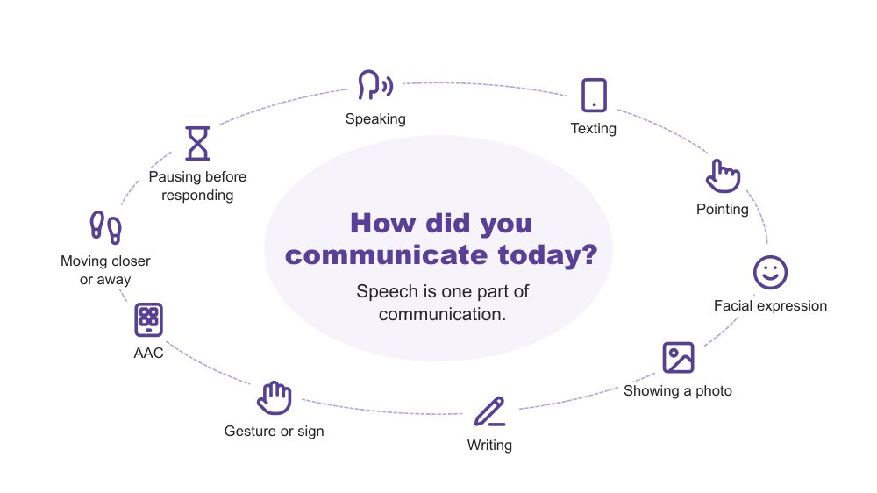 | How did you communicate today?  SUGGESTED TIME  2 min  MINUTES INTO SESSION  3 - 5

A quick warm-up showing that everyone communicates in many ways, every day.
WHAT TO DO  - Invite a quiet think: three ways participants have communicated since waking.  - Pause for about 20 seconds.  - Invite people to add one to the chat or use a reaction. Sharing is optional.  - Read out a few from the chat and reflect back the variety, for example a text message, a wave, a look, or taking a moment before answering. | KEY MESSAGES  - Everyone communicates in many ways, every day. Speech is one part of communication.

YOU MIGHT SAY
Let's start with a quick, quiet think. Since you woke up today, how have you communicated? See if you can think of three different ways.
If you are happy to, pop one in the chat.
We all move between different ways of communicating, often without noticing. Right now you are using the chat, reactions, your face on camera or not, and choosing when to unmute. Every way on this slide is real communication. No way is more valid than another.

KEEP IN MIND
- Keep this brief (1 - 1.5 minutes). It is a warm-up, not a discussion.
- Do not use percentages or claims about how much of communication is spoken or non-spoken.

Background Many students have heard "use your words" or "just ask" at school. This is a reminder for educators that pointing, a device, a message, a look or moving away are all ways of communicating. The online room is a useful example: people are already choosing between chat, reactions, speaking and silence.

SESSION 2 | Communication, Connection and Daily Capacity | SLIDE 3 of 18

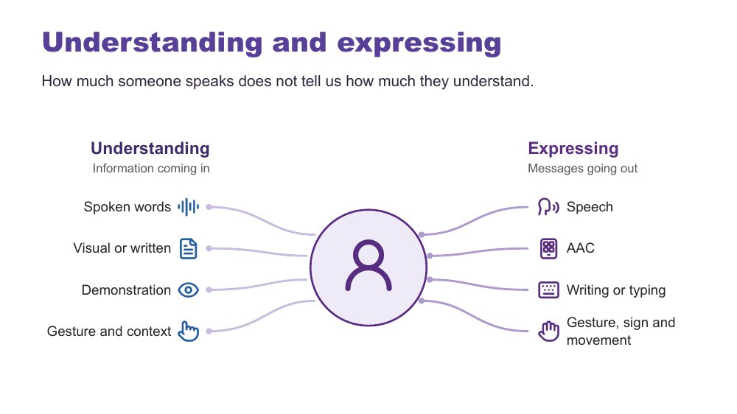 | Understanding and expressing  SUGGESTED TIME  2 min  MINUTES INTO SESSION  5 - 7

Separate understanding (receptive) from expressing (expressive) communication.
WHAT TO DO  - Explain that Autistic people have varied communication profiles.  - Explain that someone may express a great deal but need support to understand spoken information, and someone else may understand more than they can easily express.  - Note that communication can change depending on the person, place, demands and how someone is feeling.  - Explain AAC in plain terms (see the background notes).  - Ask participants to think privately: what communication access do your room, your subject and your tasks provide? | KEY MESSAGES  - How much someone speaks does not tell us how much they understand.  - Do not assume fluent speech means full understanding. Do not assume limited speech means limited understanding.  - Expressive and receptive communication do not necessarily look the same.

KEEP IN MIND
- Do not teach gestalt language processing (GLP) or Natural Language Acquisition stages here. It is background only.
- Do not ask participants to identify or diagnose a student as a gestalt language processor.
- Refer individual assessment or intervention questions to the student's speech pathologist or relevant team. If a detailed question comes up in the chat, acknowledge it and suggest this.

Background Receptive communication means how a person receives and makes sense of information. In secondary school this includes instructions from several teachers a day, subject-specific vocabulary, questions, class discussion, assessment information, corridor and break-time language, notices, changes to the timetable and information about what is happening next. Expressive communication means how a person shares messages, ideas, feelings and choices through any communication method. AAC (augmentative and alternative communication) may include gesture, signs, a communication board or book, typing or a communication device; some people use it alongside speech and some instead of speech. Echolalia means repeating words or phrases, immediately or later, and can have communicative meaning. Gestalt language processing is a term used in a proposed account of learning language through larger phrases or chunks; the two terms are not interchangeable. Hutchins et al. (2024) question the evidence for these categories and stages. This does not diminish the value of repeated or scripted language: consider the possible context, intent and meaning, listen before correcting the form, and notice when and where it occurs and what follows. A student does not need a GLP label before their communication is respected or supported.
RESOURCES
- Hutchins et al. (2024) - https://doi.org/10.1177/23969415241249944

SESSION 2 | Communication, Connection and Daily Capacity | SLIDE 4 of 18

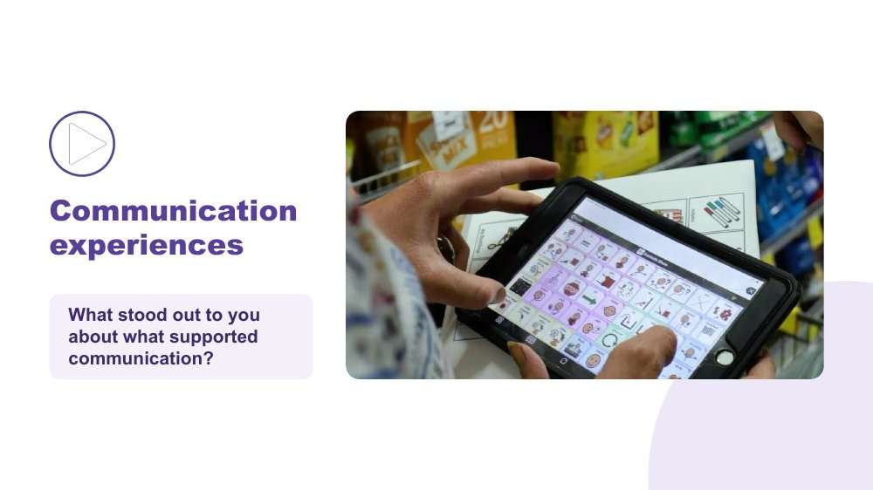 | Communication experiences  SUGGESTED TIME  4 min  MINUTES INTO SESSION  7 - 11  GROUPING  Whole group

Hear Autistic people describe what helps them communicate.
WHAT TO DO  - Share your screen with computer sound turned on, and check captions are showing.  - Read the prompt: "As you watch, notice what supports communication. Choose one idea that stands out to you."  - Play the video (around 2.5 minutes).  - Stop sharing or click once to reveal the question.  - Invite responses in the chat or by unmuting. Read out one or two. | KEY MESSAGES  - There is no single Autistic communication profile. Autistic people describe what helps them communicate in many different ways.  - A student's AAC needs to be available where communication happens, in every period and with every teacher, not only during a specific activity or therapy session.

YOU MIGHT SAY
As you watch, notice what supports communication. Choose one idea that stands out to you.
What stood out to you about what supported communication? Pop it in the chat, or unmute if you would rather say it.

ACTIVITY | Video and brief whole-group response in the chat whole group · 4 minutes
What stood out to you about what supported communication?
- Watch the clip.
- Add one idea to the chat, or unmute.
- Facilitator reads out one or two.
Bring the room back
- What communication strengths did you notice?
- What did another person do that helped?
- What difference did the environment or available communication method make?

KEEP IN MIND
- Let the voices in the video lead. Avoid summarising or generalising what speakers said.
- Use accurate, edited captions (not auto-generated only) and have a transcript available. The producer can paste the transcript link in the chat if one has been supplied.
- Test screen sharing with sound before the session. If video lags for participants, have the producer play it or share the file.

Background AAC adds to or provides an alternative to speech. In secondary school this may include signs, communication boards or books, typing, text-based tools and speech-generating devices, and it may be used alongside speech. It needs to be available in every class, not only in some rooms or with some teachers. The educator's role is not to assess or prescribe AAC. The focus is recognising and supporting the student's ways of communicating and working with the student, family and relevant team.

SESSION 2 | Communication, Connection and Daily Capacity | SLIDE 5 of 18

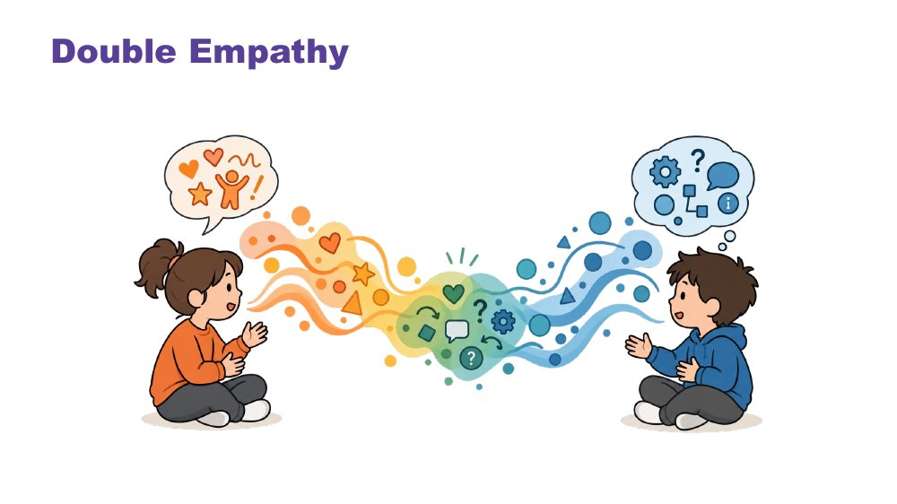 | Double empathy  SUGGESTED TIME  3 min  MINUTES INTO SESSION  11 - 14

Explore interaction and connection without treating one social style as the standard.
WHAT TO DO  - Explain double empathy: when people have different experiences and ways of communicating, understanding one another can be more difficult in both directions.  - Ask whose expectations shape an interaction and what would make connection safer or clearer.  - Consider the expectations operating during class discussion, group work, corridors, break times, online and interactions with different teachers and peers.  - Invite a short chat response if the group is ready: one place in the secondary day where expectations about interaction are strongest.  - Use "how each student connects" throughout the discussion. | KEY MESSAGES  - Connection does not need to look one way.  - Interaction is shaped by expectations and context as well as by the student.  - Social misunderstanding does not automatically sit within the Autistic student.

YOU MIGHT SAY
Whose expectations are shaping this interaction?

KEEP IN MIND
- Move away from locating every social misunderstanding within the Autistic student.

SESSION 2 | Communication, Connection and Daily Capacity | SLIDE 6 of 18

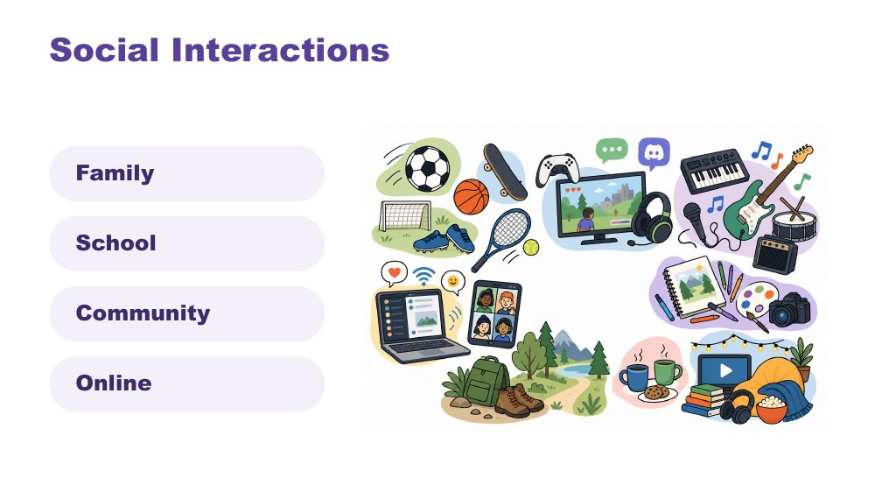 | Social interactions  SUGGESTED TIME  2 min  MINUTES INTO SESSION  14 - 16

Widen the picture of how students interact, across family, school, community and online.
WHAT TO DO  - Identify a range of ways a student may interact, for example 1:1, parallel engagement, sharing deep knowledge of an interest (info dumping), gaming or online connection, irregular contact.  - Make connections to culture.  - Name in-person, online and third spaces without making assumptions about a student's communities.  - Move straight on to the discussion, which puts this into practice. | KEY MESSAGES  - Connection can occur in person, online and in third spaces, and each student's experience is individual.  - For many adolescents, online connection and shared-interest groups are real and valued connection.

KEEP IN MIND
- Do not ask participants to disclose a student's online activity, identity or community membership.

SESSION 2 | Communication, Connection and Daily Capacity | SLIDE 7 of 18

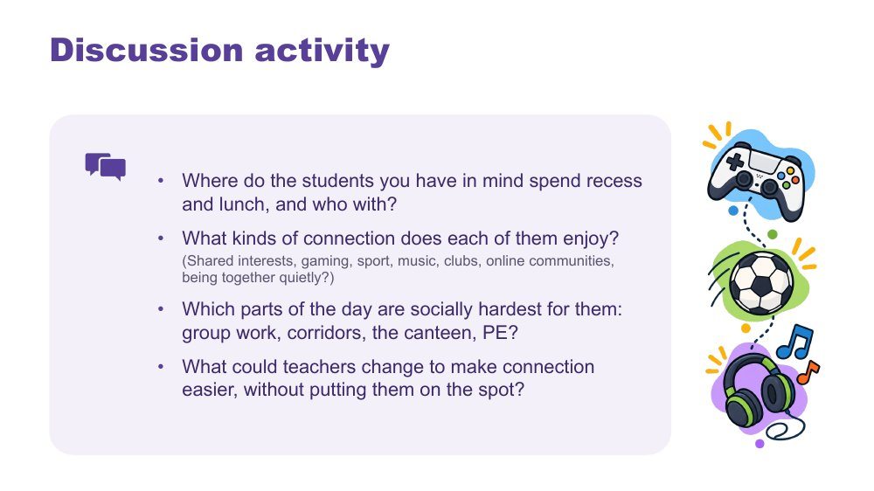 | Discussion activity: connection  SUGGESTED TIME  7 min  MINUTES INTO SESSION  16 - 23  GROUPING  Pairs or trios in breakout rooms  PARTICIPANT GUIDE  Participant Guide - Connection discussion

Apply the ideas about connection to the students participants have in mind.
WHAT TO DO  - Ask the producer to paste the four questions into the chat before opening breakout rooms. They are also in the Participant Guide.  - Open breakout rooms in pairs or trios for about 5 minutes, allowing about a minute each way for rooms to open and close. Remind people: initials or roles only, and breakout rooms are not recorded.  - Offer a main-room alternative: anyone who prefers can stay, think through the questions privately, or add thoughts to the chat.  - Broadcast a one-minute warning.  - Bring everyone back and take one or two responses from the chat or by voice, focusing on what teachers could change. | KEY MESSAGES  - Connection can look different for each student, including online communities, clubs and shared interests.  - Small changes by teachers can make connection easier without singling a student out.

ACTIVITY | Guided discussion in breakout rooms, with a main-room alternative pairs or trios in breakout rooms · 7 minutes (about 5 in breakout rooms, plus about a minute each way for rooms to open and close)
Where do the students you have in mind spend recess and lunch, and who with?
- Where do the students you have in mind spend recess and lunch, and who with?
- What kinds of connection does each of them enjoy? (Shared interests, gaming, sport, music, clubs, online communities, being together quietly?)
- Which parts of the day are socially hardest for them: group work, corridors, the canteen, PE?
- What could teachers change to make connection easier, without putting them on the spot?
Bring the room back
- What could teachers change to make connection easier, without putting them on the spot?

KEEP IN MIND
- Do not ask participants to disclose a student's online activity, identity or community membership.
- Avoid reading difference as a lack of connection. Some students prefer to spend recess and lunch alone or in a quiet space.
- Teachers may not know where a student goes at recess and lunch. That is a fair answer and a question to follow up.

Background If the group needs examples for the last question: giving group roles in advance, letting students choose partners or groups, not calling on a student without warning, and making a quiet space or club available at lunch.

SESSION 2 | Communication, Connection and Daily Capacity | SLIDE 8 of 18

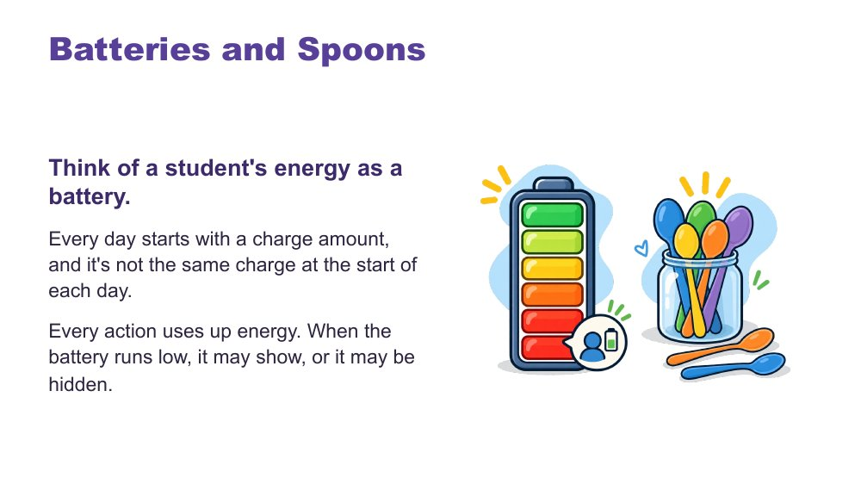 | Batteries and spoons  SUGGESTED TIME  2 min  MINUTES INTO SESSION  23 - 25

Give a shared language for energy and capacity.
WHAT TO DO  - Talk through the battery image.  - Introduce spoons as language many in the Autistic community use.  - Finish with recharging: the right supports can restore some capacity.  - Let people know they will use this language in the day map shortly. | KEY MESSAGES  - Each day starts with a different charge.  - The right supports can recharge.

YOU MIGHT SAY
Think of a student's energy as a battery. Every day starts with a charge amount, and it's not the same charge at the start of each day. Every action uses up energy. When the battery runs low, it may show, or it may be hidden.
In the Autistic community, many like to describe this as having a set of spoons. Each action uses up one or some spoons. When "spoons are low", actions are hard to manage.
You can recharge! The right supports can regain some battery charge or extra spoons.

SESSION 2 | Communication, Connection and Daily Capacity | SLIDE 9 of 18

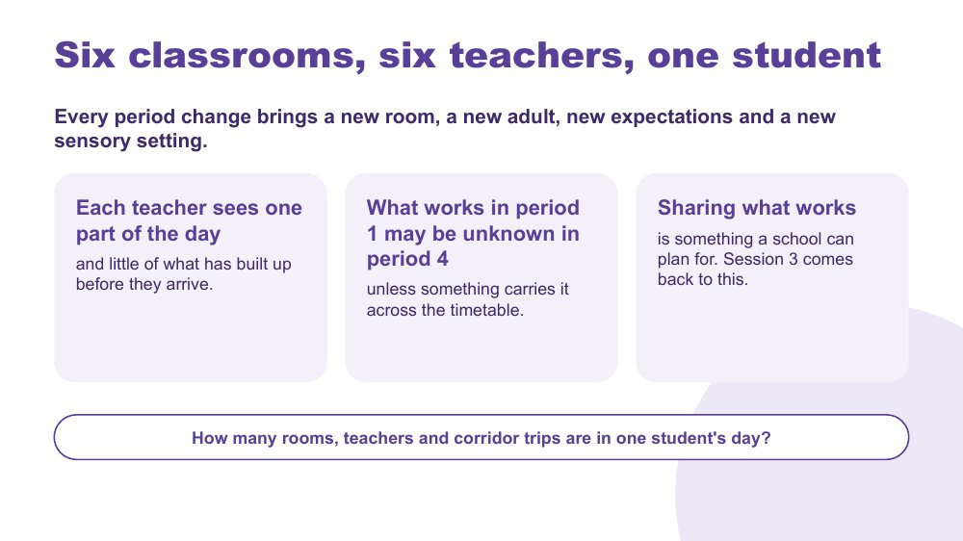 | Six classrooms, six teachers, one student  SUGGESTED TIME  3 min  MINUTES INTO SESSION  25 - 28

Show the particular challenge of secondary school: the day is split across many rooms, teachers and expectations, and no one teacher sees all of it.
WHAT TO DO  - Read the heading and the first line.  - Ask the question at the bottom of the slide and give people a moment to count. Invite a number in the chat.  - Point out that each teacher sees one part of the day and little of what has built up before the student arrives.  - Explain that what works in period 1 may be unknown in period 4 unless something carries it across the timetable.  - Explain that sharing what works is something a school can plan for. Online Session 3 comes back to this, including a one-page profile written with the student and shared with every teacher. | KEY MESSAGES  - Every period change brings a new room, a new adult, new expectations and a new sensory setting.  - Each teacher sees one part of the day and little of what has built up before they arrive.  - What works in period 1 may be unknown in period 4 unless something carries it across the timetable.  - Sharing what works is something a school can plan for.

YOU MIGHT SAY
Think about one student's day from period 1 to period 6. How many rooms, teachers and corridor trips is that? Pop a number in the chat if you like.
Each of us sees one part of that day. What works in period 1 may be unknown in period 4 unless something carries it across the timetable.
Sharing what works is something a school can plan for. We will come back to this next session.

KEEP IN MIND
- Teachers may hear this as more work. It usually means less: information shared once saves each teacher working it out again.
- Keep the example to an ordinary, recognisable day.

Background Moving between periods adds to the load already discussed: leaving one task, moving through busy corridors, and switching to a new subject, teacher and set of expectations. A student may manage well with one teacher and struggle with another because the information about what helps was not passed on.
Thread Leads into the day map on the next slide. Online Session 3 offers supports that travel and predictability across the timetable as design options.

SESSION 2 | Communication, Connection and Daily Capacity | SLIDE 10 of 18

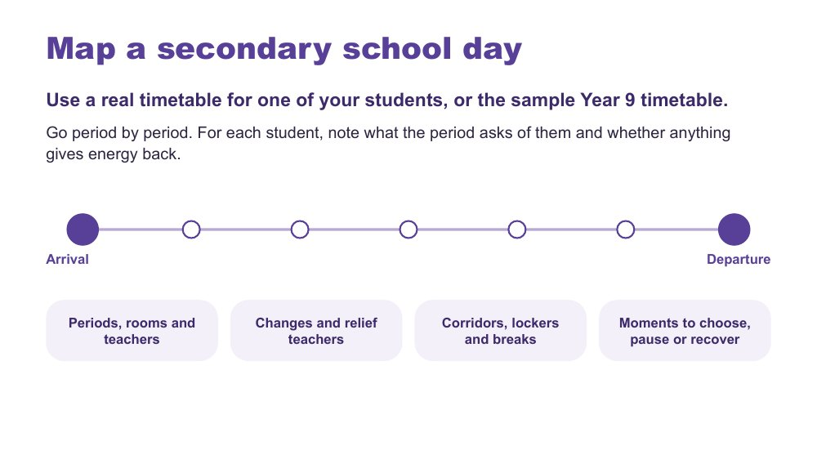 | Map a secondary school day  SUGGESTED TIME  9 min  MINUTES INTO SESSION  28 - 37  GROUPING  On your own in the main room, or pairs or trios in breakout rooms  PARTICIPANT GUIDE  Participant Guide - Map a secondary school day

Map one secondary school day period by period, and mark what each period costs or gives back for each of the students participants have in mind.
WHAT TO DO  - Ask participants to open the day map table in the Participant Guide (digital or printed). Anyone without a real timetable for one of their students can use the sample Year 9 timetable; the producer shares it.  - Explain the task: go period by period, from arrival to departure. For each period, note the room, the teacher and what happens. For each student (columns A, B and C), mark C if it costs energy, L if it lightens or gives energy back, ? if not sure yet.  - Offer two ways to work: stay in the main room and map individually (cameras and microphones off is fine), or join a breakout room to map alongside one or two colleagues and talk it through.  - Ask the producer to paste the prompt and the C / L / ? key into the chat, then open optional breakout rooms in pairs or trios for about 7 minutes.  - Encourage subject teachers to map the whole day, not only their own period.  - Broadcast a one-minute warning, bring everyone back and let them know the next slide adds to the same map. | KEY MESSAGES  - No single teacher sees the whole day. The map puts it in one place.  - A ? is useful. It shows what to ask the student, family or other staff.  - The map is a working picture to extend, not a judgement of the student or school.

ACTIVITY | Individual map in the Participant Guide, or mapping alongside colleagues in breakout rooms on your own in the main room, or pairs or trios in breakout rooms · about 7 minutes
Use a real timetable for one of your students, or the sample Year 9 timetable. Go period by period. For each student, note what the period asks of them and whether anything gives energy back.
- Use the day map table, from arrival to departure.
- For each period, note the room, the teacher and what happens.
- For each student, mark C (costs energy), L (lightens or gives energy back) or ? (not sure yet).
- Think about changes and relief teachers; corridors, lockers and breaks; moments to choose, pause or recover.
- In a breakout room, talk about patterns across the day, not the student. Keep the map private unless you choose to discuss it.
Close: The map is a working picture to extend, not a judgement of the student or school.

KEEP IN MIND
- Avoid names, school identifiers, timetable details that identify a student, or unique incidents, especially in breakout rooms.
- Subject teachers may map only their own period. Encourage the whole day.
- A period can be both C and L. Let participants mark both.
- Participants may notice things they do not yet know about a student's day. Mark these with ? and carry them forward.

Background The sample Year 9 timetable is for anyone who does not know a student's full timetable or would rather not use a real one. A real timetable usually gives a more useful picture if participants have one.
Thread Online Session 3 builds on this map.

SESSION 2 | Communication, Connection and Daily Capacity | SLIDE 11 of 18

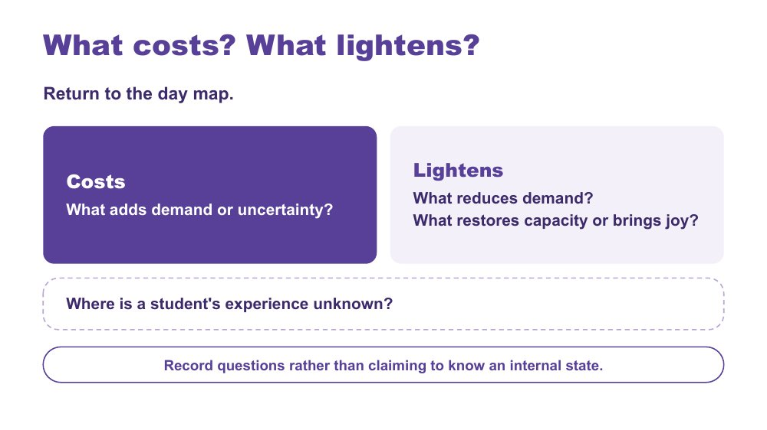 | What costs? What lightens?  SUGGESTED TIME  5 min  MINUTES INTO SESSION  37 - 42  GROUPING  On your own  PARTICIPANT GUIDE  Participant Guide - What costs? What lightens?

Extend the day map to show demand, relief and what is not yet known.
WHAT TO DO  - Ask participants to return to the day map.  - Ask them to note what adds demand or uncertainty (costs), for example crowded corridors, a relief teacher, a room change or an assessment task being handed out.  - Ask them to note what reduces demand, restores capacity or brings joy (lightens).  - Ask them to add questions where a student's experience is unknown.  - Link back to the battery language: what drains, what recharges.  - After about 3 minutes, invite one or two patterns in the chat under three headings: costs, lightens, questions. Read out one or two. | KEY MESSAGES  - A single moment sits within everything that has built up across the day, good and hard.  - The map should include what lightens and restores as well as what costs.  - Record questions rather than claiming to know an internal state.

ACTIVITY | Extend the secondary day map, with optional chat shares on your own · about 4 minutes
What costs? What lightens? Where is a student's experience unknown?
- Add to your C marks: what adds demand or uncertainty?
- Add to your L marks: what reduces demand, restores capacity or brings joy?
- Add questions where the student's experience is not known.
- If you like, add one pattern to the chat: costs, lightens or a question.
Close: Look for patterns in the day that can inform what you carry into design.

KEEP IN MIND
- Do not turn the map into a score or a claim about internal state.
- Do not infer a student's internal state from a single behaviour or moment.
- Include strengths, joy, safe connection and belonging alongside costs.

Background Something can be enjoyable, valued or successfully completed and still require considerable effort. What costs or lightens will differ between students, and may differ for the same student across contexts and days.

SESSION 2 | Communication, Connection and Daily Capacity | SLIDE 12 of 18

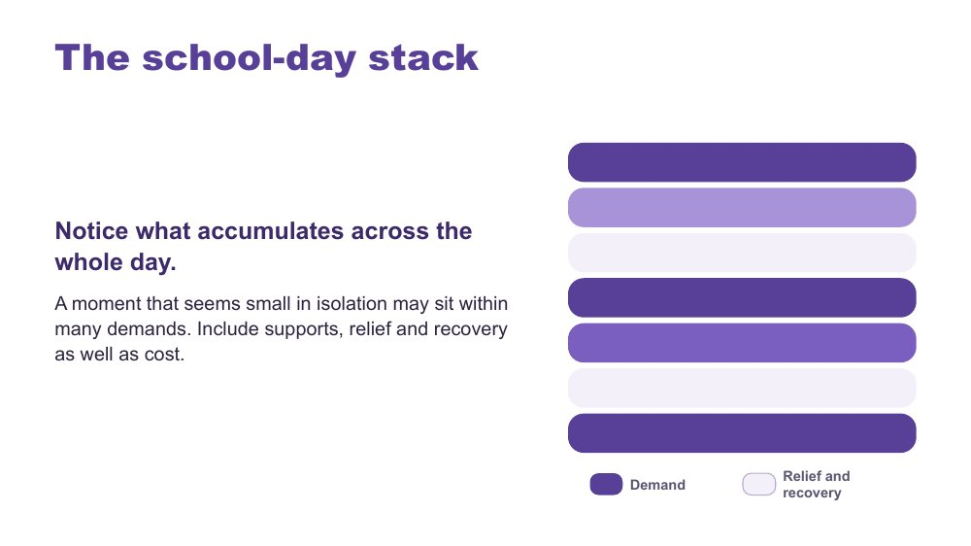 | The school-day stack  SUGGESTED TIME  2 min  MINUTES INTO SESSION  42 - 44

Show how demand accumulates across the whole day.
WHAT TO DO  - Use the stack model as presented.  - Point out that darker bars show demand and lighter bars show relief and recovery.  - Point out that no single teacher sees the whole stack. Each sees one period of it.  - Invite participants to glance back at their own map and notice where demand builds up.  - Keep the discussion qualitative. | KEY MESSAGES  - A moment that seems small in isolation may sit within many demands.  - Include supports, relief and recovery as well as cost.

KEEP IN MIND
- The stacked bars are a visual cue only. Do not score students.

SESSION 2 | Communication, Connection and Daily Capacity | SLIDE 13 of 18

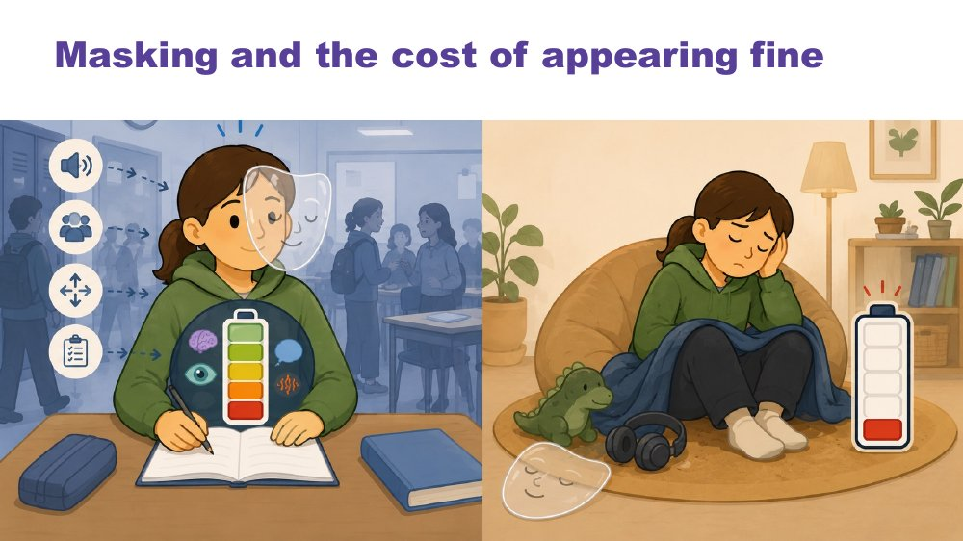 | Masking and the cost of appearing fine  SUGGESTED TIME  2 min  MINUTES INTO SESSION  44 - 46

Name what may be missed if educators look only at outward behaviour.
WHAT TO DO  - Introduce masking in relation to identity and belonging.  - Pose the four questions for participants to think about privately.  - Ask what may be missed if educators look only at outward behaviour or task completion.  - Mention that the next few slides touch on burnout and School Can't, and people are welcome to step away and come back. | KEY MESSAGES  - What is visible does not tell the whole story.  - What is visible does not provide a complete account of capacity, identity or belonging.

KEEP IN MIND
- Avoid assuming that a student is coping because they are quiet, compliant or completing work.
- Include strengths, joy, safe connection and belonging alongside costs.

Background Prompts to pose: What might the student be working hard to manage or hide? Where can they be recognised and included? What supports belonging without requiring them to appear less Autistic? What does the student want others to understand?

SESSION 2 | Communication, Connection and Daily Capacity | SLIDE 14 of 18

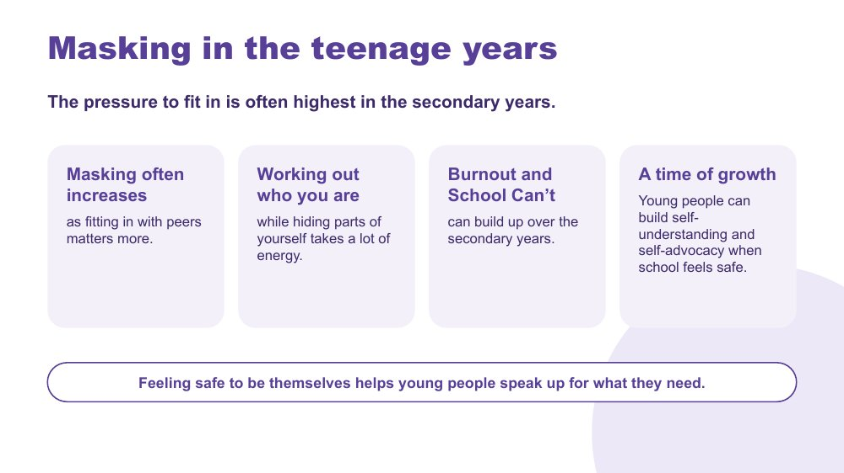 | Masking in the teenage years  SUGGESTED TIME  3 min  MINUTES INTO SESSION  46 - 49

Look at how masking and capacity change in the teenage years, including the chance for growth.
WHAT TO DO  - Read the heading and the first line.  - Talk through the four points on the slide: masking often increases, working out who you are while hiding parts of yourself, burnout and School Can't, and a time of growth.  - Mention burnout and School Can't briefly and respectfully. Online Session 4 returns to working with families.  - Finish with the last line: feeling safe to be themselves helps young people speak up for what they need. | KEY MESSAGES  - The pressure to fit in is often highest in the secondary years, and masking often increases.  - Working out who you are while hiding parts of yourself takes a lot of energy.  - Burnout and School Can't can build up over the secondary years.  - Young people can build self-understanding and self-advocacy when school feels safe.

YOU MIGHT SAY
The pressure to fit in is often highest in the secondary years. Masking often increases as fitting in with peers matters more.
These are the years when young people work out who they are. Doing that while hiding parts of yourself takes a lot of energy.
Burnout and School Can't can build up over the secondary years.
It is also a time of growth. When school feels safe, young people can build self-understanding and speak up for what they need.

KEEP IN MIND
- Talk about School Can't calmly and respectfully. It is not defiance.
- Some participants may recognise a family member or themselves. Remind people they can turn their camera off or step away and return.
- Do not ask participants to share personal or identifying stories.

Background Many participants ask for content about the teenage years. This slide connects capacity, masking and identity to the secondary years, and leads toward student voice and self-advocacy in Online Session 4.
Thread Self-advocacy and student voice return in Online Session 4 (adolescents in their own meetings).

SESSION 2 | Communication, Connection and Daily Capacity | SLIDE 15 of 18

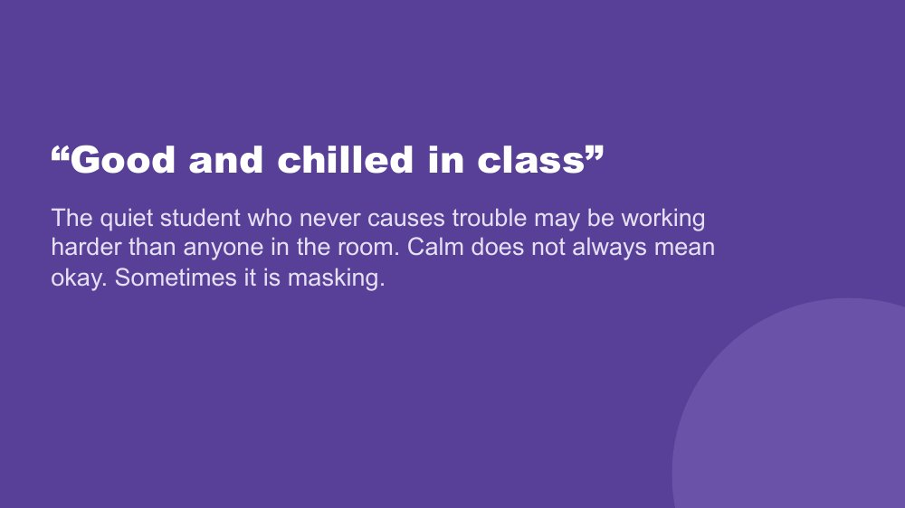 | “Good and chilled in class”  SUGGESTED TIME  2 min  MINUTES INTO SESSION  49 - 51

Protect the students least likely to be noticed: calm and quiet do not always mean okay.
WHAT TO DO  - Read the slide.  - Ask the question and invite participants to think about it privately: who is your quietest Autistic student, and what do you actually know about their experience?  - Give people a moment to think, then move into the discussion activity. | KEY MESSAGES  - The quiet student who never causes trouble may be working harder than anyone in the room.  - Calm does not always mean okay. Sometimes it is masking.

YOU MIGHT SAY
Who is your quietest Autistic student, and what do you actually know about their experience? Keep this one to yourself.

KEEP IN MIND
- Some participants may feel uncomfortable with this question. You do not need to resolve that here. The discussion that follows gives them a chance to think it through.
- Keep the question private. Do not ask for answers in the chat or aloud.

Background Quiet, compliant presentations can hide unmet needs, and a student who masks well may be the last to be offered support.

SESSION 2 | Communication, Connection and Daily Capacity | SLIDE 16 of 18

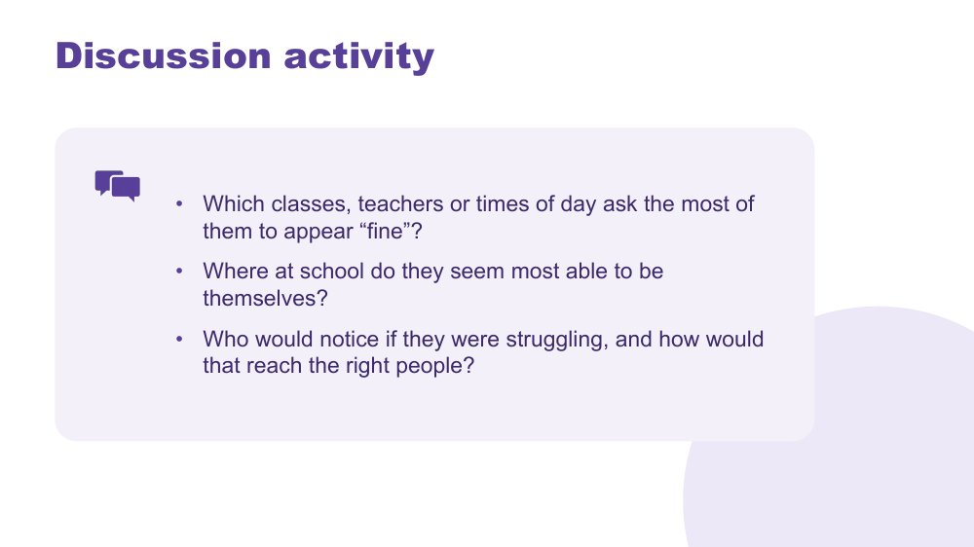 | Discussion activity: masking  SUGGESTED TIME  3 min  MINUTES INTO SESSION  51 - 54  GROUPING  On your own, whole group for the last question  PARTICIPANT GUIDE  Participant Guide - Masking discussion

Apply masking to the students participants have in mind.
WHAT TO DO
- Ask the producer to paste the three questions into the chat. They are also in the Participant Guide.
- Give about 2 minutes of private reflection. The first two questions stay private.
- Invite responses to the last question only, in the chat or by unmuting. Read out one or two.

ACTIVITY | Private reflection with optional chat response on your own, whole group for the last question · about 3 minutes
Which classes, teachers or times of day ask the most of them to appear "fine"?
- Which classes, teachers or times of day ask the most of them to appear "fine"?
- Where at school do they seem most able to be themselves?
- Who would notice if they were struggling, and how would that reach the right people?
Bring the room back
- Who would notice if they were struggling, and how would that reach the right people?

KEEP IN MIND
- Avoid assuming that a student is coping because they are quiet, compliant or completing work.
- Keep examples anonymised. The chat is visible to everyone and may be saved.
- The last question is about how information moves between staff, such as subject teachers, the year level coordinator, learning support, wellbeing staff and home. Keep the focus on how the school shares information, not on individual staff who missed something.

SESSION 2 | Communication, Connection and Daily Capacity | SLIDE 17 of 18

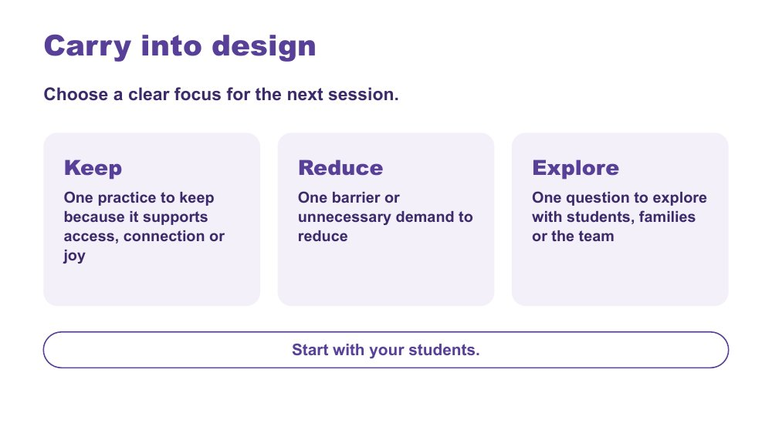 | Carry into design  SUGGESTED TIME  3 min  MINUTES INTO SESSION  54 - 57  GROUPING  On your own  PARTICIPANT GUIDE  Participant Guide - Carry into design

Consolidate the school-day inquiry and choose a focus for Online Session 3.
WHAT TO DO  - Invite participants to identify one practice to keep, one barrier to reduce and one question to explore, in the Participant Guide.  - Ask participants to tick whether their Reduce item is a lesson, an assessment task or a handover. They will use this in Online Session 3.  - Keep responses private unless participants choose to share.  - Ask participants to keep their map for the design activity next session.  - Preview the move from the secondary day map to one practical design change. | KEY MESSAGES  - Design should protect what supports access, connection and joy as well as reduce barriers.  - Small changes to the environment, communication or rhythm of the day may create meaningful changes in access.  - Unanswered questions can guide consultation with the student, family and team.  - Start with your students.

ACTIVITY | Carry into design (Keep, Reduce, Explore) in the Participant Guide on your own · about 2 minutes
Choose a clear focus for the next session.
- Keep: one practice to keep because it supports access, connection or joy.
- Reduce: one barrier or unnecessary demand to reduce.
- Tick: lesson, assessment task or handover.
- Explore: one question to explore with students, families or the team.
Close: Keep your map and your Keep, Reduce, Explore notes for Online Session 3.

Thread Leads directly into the Online Session 3 design brief.

SESSION 2 | Communication, Connection and Daily Capacity | SLIDE 18 of 18

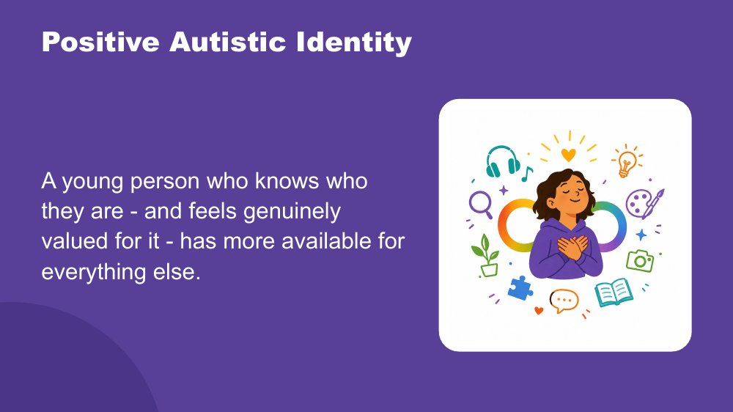 | Positive Autistic identity  SUGGESTED TIME  3 min  MINUTES INTO SESSION  57 - 60

Close the session by returning to the students participants have in mind, seen now with a fuller picture.
WHAT TO DO  - Let the room settle before you begin. You might invite people to turn off self-view or look away from the screen.  - Read the spoken close slowly, with the image on the screen.  - When you finish, give people a moment of quiet before closing.  - Thank participants, give the date of Online Session 3 and ask them to bring their map and Keep, Reduce, Explore notes. | KEY MESSAGES  - The effort is more than masking. It includes managing sensory, social, communication and executive demands every day in settings not designed for Autistic people.  - A positive Autistic identity is linked in research to better mental health and wellbeing.  - Belonging comes first. When a student does not have to manage their identity on top of everything else, they have more energy for learning and connection.  - Choice helps. Real choice over how they communicate, where they sit and when they step back reduces the load.  - Knowing other Autistic people who share their experience helps.

YOU MIGHT SAY
Across these first two sessions, you have been building a picture of the students you have in mind.
How the world arrives through their senses, more fully, more specifically, less filtered. How their brain builds understanding from the detail up, focuses deeply, and thinks in ways that produce real and specific strengths. How their internal world works. How they reach toward other people, and what that costs when the conditions are not designed for them.
Managing all of that, every day, in a world that was largely built for a different nervous system, takes resources. Sensory management. Social interpretation. Executive effort. Communication across a gap. Holding it together when the signals inside are not arriving clearly. And sometimes, performing fine when fine is not what is happening.
A young person who knows who they are - and feels genuinely valued for it - has more of those resources available for everything else.
Research supports what many Autistic adults already know: a positive sense of Autistic identity is connected to better mental health, less anxiety, and greater wellbeing. Belonging is the precondition for all of it. When a young person does not need to spend resources managing their identity on top of everything else, those resources become available for learning, connection, and self-knowledge.
Agency matters too, genuine choice over how they communicate, where they sit, when they step back. And knowing that other Autistic people share their experience, that Autistic adults have found belonging and purpose, is protective in its own right.
These students are not alone in this. They are part of something.
The deepest thing you can do is support them to know themselves, and to know that who they are is worth knowing.

KEEP IN MIND
- The spoken close draws together what was covered across Online Sessions 1 and 2. Read it as written and let participants make their own connections. You do not need to explain it.
- Some participants may need a moment after the last line. Leave a few seconds of quiet; do not end the call straight after it.

Background Research on Autistic identity and wellbeing links a positive Autistic identity (knowing yourself as Autistic and valuing that) with better mental health, less anxiety and greater resilience. This is different from general self-esteem. Connection with other Autistic people adds to this. The aim is for each student to know who they are and to find people and places where that is valued, rather than to fit in. In the teenage years, when identity is forming and masking often increases, this matters even more. See Cooper, Smith and Russell (2017); Corden, Brewer and Cage (2021).
Thread Links back to the students participants brought to mind in Online Session 1. You do not need to point this out.

SESSION  3 | ONLINE · 60 MINUTES · 17 SLIDES  Designing for Access Across Secondary School

SESSION INTENT
Participants move from understanding to design by redesigning one real piece of secondary practice (a lesson, an assessment task or a handover) through an environment-first brief, a menu of support options and a universal-first accessibility check. Each person develops the change in their Participant Guide and checks it with a breakout partner, then privately tests it against the two or three students they have in mind, which opens the continuum of support, before a personal commitment.
PARTICIPANTS LEAVE WITH
- write an environment-first brief for one real lesson, assessment task or handover, free from blame or deficit labels
- match one or two support options to a known demand in that design and test it for accessibility
- check the design against the students they have in mind and locate where targeted or individual support begins on the continuum
- leave with one change to try this week in their own classes, what needs their faculty or year level team or school leaders, and who they will involve, including the student and family

RUN SHEET
Minutes in | Segment | Slides | Minutes
0 - 7 | Reconnect and students first | 1-3 | 7
7 - 14 | Brief | 4 | 7
14 - 26 | Options | 5-9 | 12
26 - 31 | Universal first | 10-11 | 5
31 - 43 | Design and breakout check | 12 | 12
43 - 48 | Check against your students | 13 | 5
48 - 56 | Continuum and NCCD | 14-16 | 8
56 - 60 | Commit and close | 17 | 4

PREPARE
☐ Participant Guide (digital or printed) for every participant: My brief, My design, My students check and Commit sections.
☐ Ask participants to bring their secondary day map and Carry into design notes (Keep, Reduce, Explore) from Online Session 2.
☐ Brief the producer: breakout pairs ready for slide 12 (about 5 minutes), plus a main-room option.
☐ Chat prompts ready to paste: brief stems, the five design steps and pair check, commitment questions.
☐ An approved composite secondary example and sample assessment task for anyone without a suitable context.
☐ Visual Supports Checklist and details of the visual supports webinar (links to confirm).
☐ Current official NCCD information to share in the chat.

Producer cues · Session 3
For the producer or co-host. At the start: admit participants, turn on captions, and paste the Participant Guide link and the session title in the chat. For each activity: paste the prompt before rooms open, broadcast a one-minute warning, and close rooms on time.
Slide | Activity | How | Time | Paste in the chat
4 | Write your brief | on your own | 7 minutes (about 5 minutes writing, 2 minutes chat share) | Choose one lesson, assessment task or handover you know well, then write an environment-first brief.
11 | Accessibility check | on your own | about 4 minutes | Run these over your draft design, then test it through use and feedback.
12 | Finish your design | on your own, then breakout pairs | 12 minutes (about 7 minutes design, 5 minutes pair check) | Develop the change in your Participant Guide.
13 | Check the design against your students | on your own | 5 minutes | Privately, test your design against each of your students.
17 | Share, refine and commit | on your own | about 4 minutes | What will you try this week, in your own classes? What needs your faculty or year level team? What needs to go to school leaders? How will students and families help refine it?

SESSION 3 | Designing for Access Across Secondary School | SLIDE 1 of 17

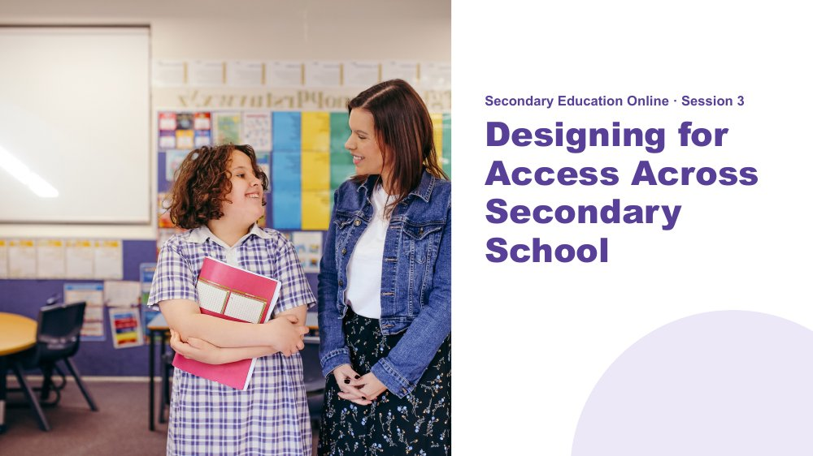 | Session 3 / Designing for Access Across Secondary School  SUGGESTED TIME  3 min  MINUTES INTO SESSION  0 - 3  PARTICIPANT GUIDE  Participant Guide - Session 3 key ideas

Reconnect with the day map and design question from last session, and shift from understanding experience to designing access across a secondary school day.
WHAT TO DO  - Welcome participants back as they join. Remind them that cameras are optional and that chat, reactions, speaking, private notes or passing all count.  - Ask them to have their Participant Guide open, with the secondary day map and Carry into design notes (Keep, Reduce, Explore) from last session to hand.  - Invite one or two people to share in the chat, using initials or roles only, anything they noticed since last session about the barrier they chose to reduce.  - Explain that this session moves from understanding students to designing the environment, task and routine around them.  - Explain that each person will produce one small change to a lesson, an assessment task or a handover that can be tried and reviewed.  - Keep the focus on environment, task and routine rather than changing the student. | KEY MESSAGES  - What we know about students informs design; it is not a list of deficits.  - A practical change should respond to a barrier or access question.

KEEP IN MIND
- Remind people they can step away from the screen at any time.
- If anyone missed Online Session 2, they can use the sample Year 9 timetable in the Participant Guide, choose any lesson, assessment task or handover they know well for their brief, and borrow their breakout partner's Keep, Reduce, Explore notes.
- Flex points if running behind: on slide 4, skip the chat share of "We could change..." lines; keep each option input on slides 6 to 9 to about two minutes and skip the chat invitations; on slide 14, give one example overall rather than one per layer. Protect the design and breakout check on slide 12.

Thread Picks up the secondary day map, costs and lighteners and the Carry into design notes (especially "Reduce") from Online Session 2.

SESSION 3 | Designing for Access Across Secondary School | SLIDE 2 of 17

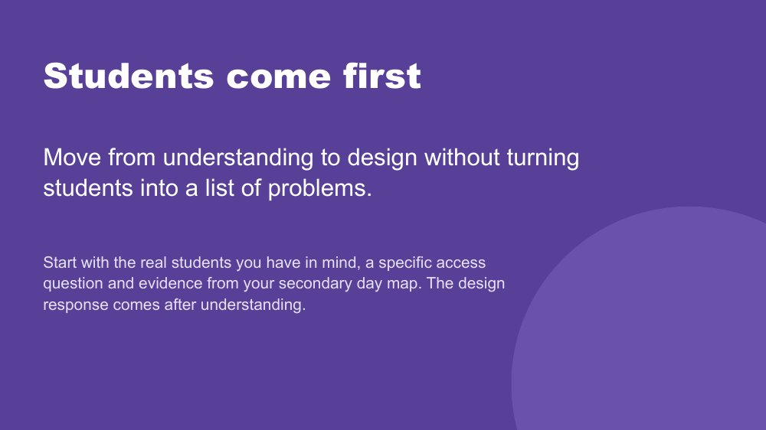 | Students come first  SUGGESTED TIME  2 min  MINUTES INTO SESSION  3 - 5

Set the principle that understanding real students comes before any design response.
WHAT TO DO  - Point to the students participants have in mind and the secondary day map from last session.  - Name that each person designs one lesson, assessment task or handover, then checks that design against the two or three students they have in mind.  - Remind participants to include only what is known, and to hold unknowns as questions.  - Ask participants to separate an observation from an interpretation, and a question from a conclusion. | KEY MESSAGES  - The student comes before the strategy.  - A design brief connects what matters for students with what can change in the environment, task or routine.  - Use the costs from the day map as things the design needs to address, and strengths and interests as things to build on.  - Unknowns remain questions for consultation.

KEEP IN MIND
- Do not use what is known about students to diagnose, rank or reduce them to support needs.
- Initials or roles only in the chat and in breakout rooms.

Thread Draws on the secondary day map from Online Session 2.

SESSION 3 | Designing for Access Across Secondary School | SLIDE 3 of 17

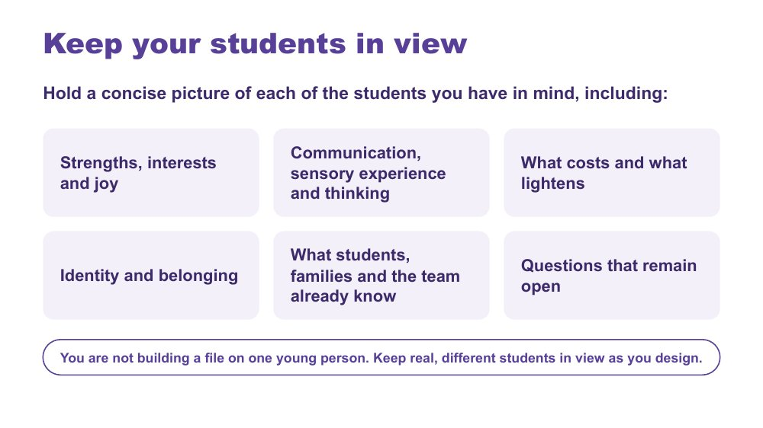 | Keep your students in view  SUGGESTED TIME  2 min  MINUTES INTO SESSION  5 - 7

A quick reminder to hold a concise picture of each student in mind while designing.
WHAT TO DO  - Keep this to about one to two minutes.  - Run through the areas on the slide as prompts, not a form to fill in.  - Invite participants to jot private notes if it helps; nothing here is shared.  - Name that participants will come back to these students later in the session, in the private check. | KEY MESSAGES  - You are not building a file on one young person. Keep real, different students in view as you design.  - Include strengths, interests and joy, communication, sensory experience, thinking, costs, lighteners, identity and belonging only where these are known or framed as questions.

KEEP IN MIND
- Do not use this to diagnose, rank or reduce students to support needs.
- Remember the quiet student described as "good and chilled in class". A calm student is not always evidence that a design is working.

Thread Recalls masking and "good and chilled in class" from Online Session 2.

SESSION 3 | Designing for Access Across Secondary School | SLIDE 4 of 17

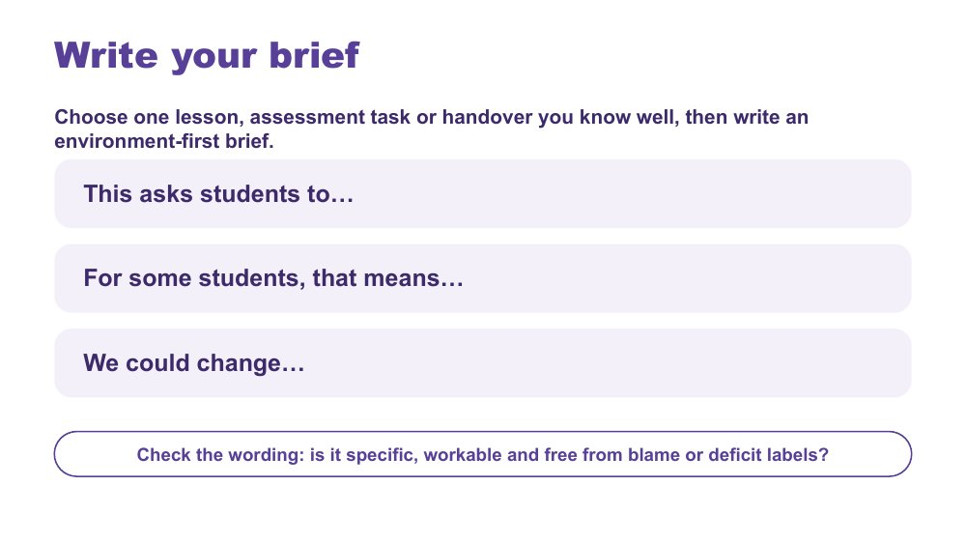 | Write your brief  SUGGESTED TIME  7 min  MINUTES INTO SESSION  7 - 14  GROUPING  On your own  PARTICIPANT GUIDE  Participant Guide - My brief

Each person chooses one lesson, assessment task or handover they know well and writes an environment-first design brief for it.
WHAT TO DO  - Ask the producer to paste the three stems into the chat.  - Ask each person to choose one lesson, assessment task or handover they know well. It may come from their "Reduce" note last session.  - Give about five minutes to complete the three stems in the Participant Guide.  - Check that the brief points to something within educator or school influence.  - Prompt participants to remove any wording that blames or labels students, for example "disorganised" or "unmotivated".  - Invite one or two people to paste their "We could change..." line into the chat, and read one aloud. | KEY MESSAGES  - A design brief connects what matters for students with what can change in the environment, task or routine.  - Unknowns remain questions for consultation.

ACTIVITY | Individual design brief in the Participant Guide, with optional chat share on your own · 7 minutes (about 5 minutes writing, 2 minutes chat share)
Choose one lesson, assessment task or handover you know well, then write an environment-first brief.
- Choose one lesson, assessment task or handover you know well.
- Complete: "This asks students to..."
- Complete: "For some students, that means..."
- Complete: "We could change..."
- Check the wording: is it specific, workable and free from blame or deficit labels?
Bring the room back
- Optional: paste your "We could change..." line into the chat.
Close: Keep this one brief active for the rest of the session.

KEEP IN MIND
- Watch for observation drifting into interpretation, or questions presented as conclusions.

Background If someone has no suitable context in mind, offer the approved composite secondary example or sample assessment task.

SESSION 3 | Designing for Access Across Secondary School | SLIDE 5 of 17

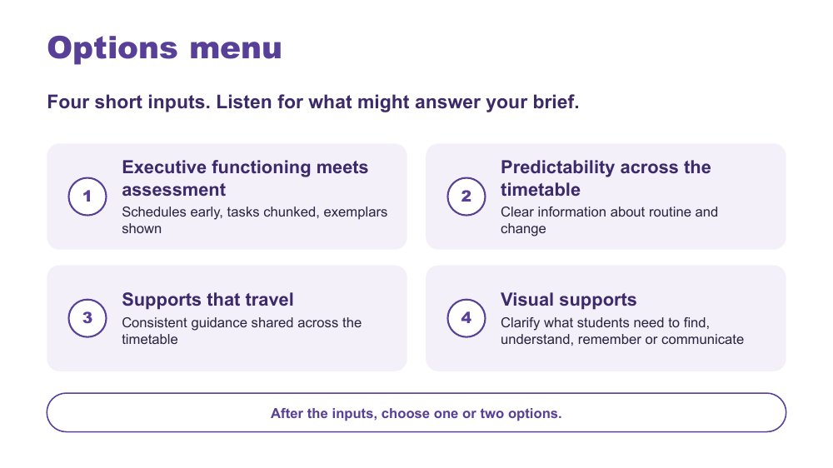 | Options menu  SUGGESTED TIME  1 min  MINUTES INTO SESSION  14 - 15

Frame the short inputs as a menu that participants listen to with their brief in front of them.
WHAT TO DO  - Ask participants to keep their brief visible, in the Participant Guide or on screen beside Zoom.  - Ask them to listen for which option might answer "This asks students to..."  - Name that there are four options, each with a short input slide.  - Keep each of the following inputs to two or three minutes.  - Invite people to note in the chat which option they are leaning towards, if they wish. | KEY MESSAGES  - Listen for what might answer your brief.

SESSION 3 | Designing for Access Across Secondary School | SLIDE 6 of 17

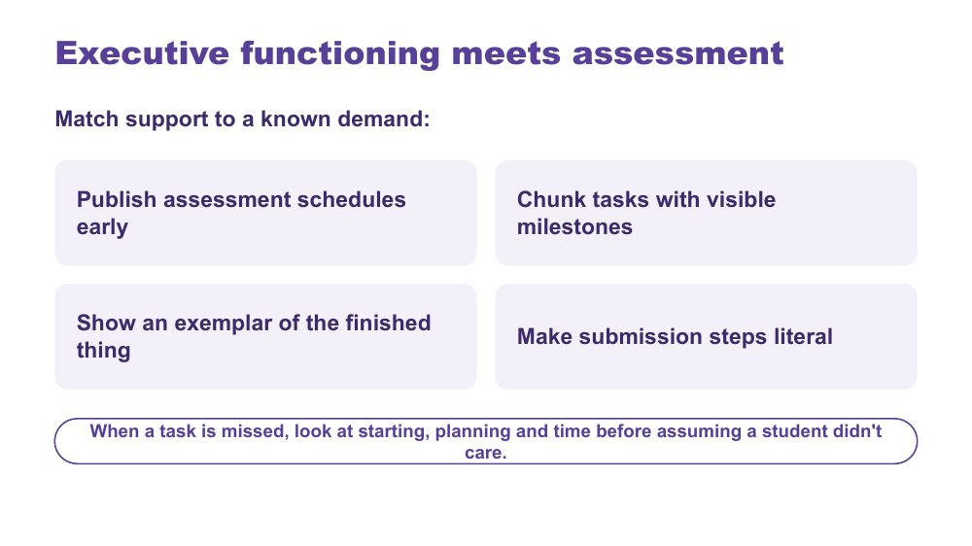 | Executive functioning meets assessment  SUGGESTED TIME  3 min  MINUTES INTO SESSION  15 - 18

Option 1 of 4: executive functioning supports matched to the known demands of assessment.
WHAT TO DO  - Keep this input to about three minutes.  - Open with a short example: a capable student misses an assessment task and gets a zero. Invite ideas in the chat about what might be going on besides motivation.  - Go through the four design moves on the slide: publish assessment schedules early, chunk tasks with visible milestones, show an exemplar of the finished thing, make submission steps literal.  - Explain the idea behind them: if a student finds it hard to hold steps in mind or to get started, put that information where they can see it, for example written first steps, instructions that stay on the class page, and a visible clock or timer.  - Ask participants to think about homework: how much of the load is organisation and time rather than the subject itself?  - Link examples to the day map and each person's brief rather than presenting a strategy checklist. | KEY MESSAGES  - In secondary, success can depend as much on organisation, planning and time as on subject knowledge.  - These supports do not change what is being assessed. They help students get organised enough to show what they know.  - A support should reduce unnecessary demand rather than increase compliance pressure.

YOU MIGHT SAY
When a task is missed, look at starting, planning and time before assuming a student didn't care.

KEEP IN MIND
- Avoid assuming that the same support works across students, subjects or contexts.
- If someone says "that's just good teaching", agree. That is the idea behind universal design, which comes next.
- Assessment policy questions may be beyond one teacher's decision. Suggest who in the school they could take them to.

Background Exemplars connect to detail-first thinking from Online Session 1: seeing the finished thing first helps a student build the whole picture. Exam access also fits here: preparation routines, managing load, and adjustments planned well before the exam.
Thread Draws on thinking and executive functioning from Online Session 1.

SESSION 3 | Designing for Access Across Secondary School | SLIDE 7 of 17

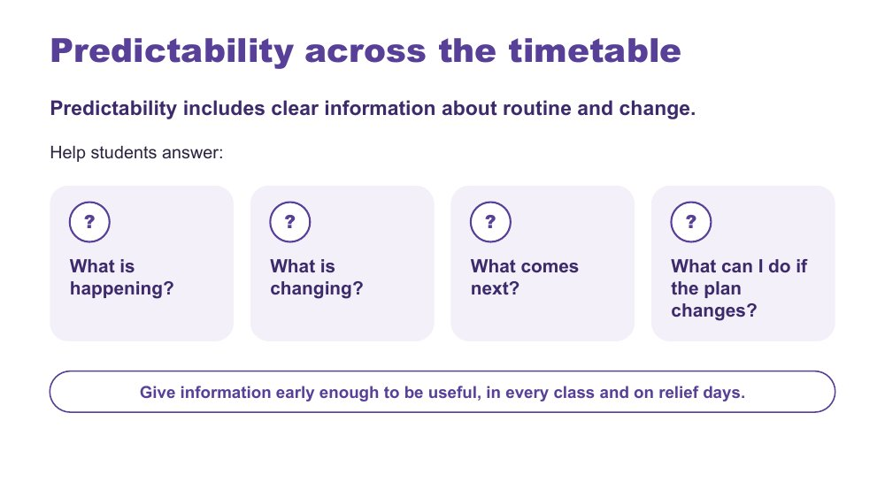 | Predictability across the timetable  SUGGESTED TIME  3 min  MINUTES INTO SESSION  18 - 21

Option 2 of 4: predictability as access to information about routine and change.
WHAT TO DO  - Keep this input to about three minutes.  - Frame predictability as access to information, not making every day the same or removing unexpected change.  - Draw attention to how much information in a secondary day is spoken, implied or held by adults, and how it can change from one period to the next.  - Connect back to the day map from last session: when something changes, how do students find out?  - Use the four questions on the slide to examine what information is available to students.  - Mention relief days: a relief plan that keeps the class's usual routines is part of predictability.  - If needed, use the example below. | KEY MESSAGES  - Predictability is access to information, not a promise that nothing will change.  - Clear information about change can be just as important as information about routine.  - In practice, predictability means keeping routines consistent, giving warning before transitions, and telling students about changes in more than one way.

YOU MIGHT SAY
If I couldn't rely on remembering what someone had told me, how would I know what was happening across today's timetable?
Predictability is not the absence of change. It includes having accessible information when change happens.

Background Secondary example if needed: a Year 9 student arrives at period 3 to find a relief teacher, a different room and a changed task. How would they know before they arrive? Is the change shown somewhere they can check, such as the class page or the timetable app? Does the relief plan keep the class's usual start routine? Can they see what happens next? Do they have an accessible way to ask a question or say they need more information or support? Students may otherwise be expected to listen, remember, infer or ask in order to know what is happening.
Thread Links back to the secondary day map and "Six classrooms, six teachers, one student" from Online Session 2.

SESSION 3 | Designing for Access Across Secondary School | SLIDE 8 of 17

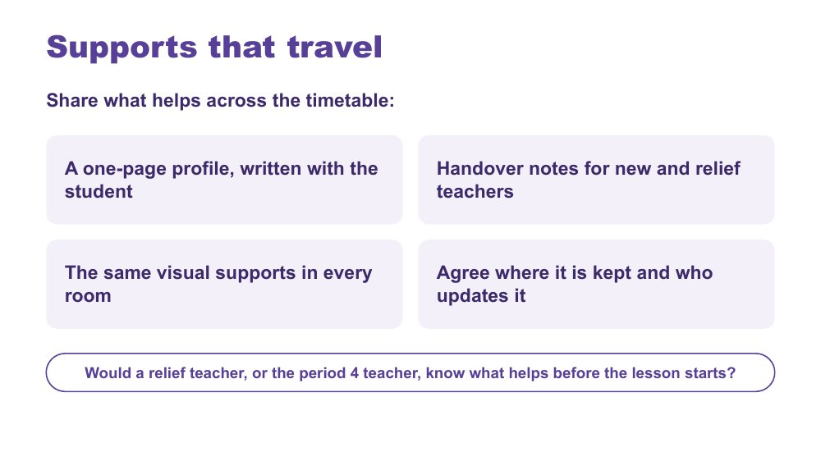 | Supports that travel  SUGGESTED TIME  2 min  MINUTES INTO SESSION  21 - 23

Option 3 of 4: supports that stay consistent across subjects, teachers, rooms and relief days.
WHAT TO DO  - Keep this input to about two minutes.  - Refer back to "Six classrooms, six teachers, one student" from Online Session 2. Shared guidance is one response to it.  - Ask where a support currently depends on one teacher knowing the student well.  - Walk through the four points on the slide: a one-page profile written with the student; handover notes for new and relief teachers; the same visual supports in every room; agreeing where the information is kept and who updates it.  - Ask the question on the slide: would a relief teacher, or the period 4 teacher, know what helps before the lesson starts?  - Separate useful guidance from unnecessary personal detail. | KEY MESSAGES  - A support that works in one lesson may not work if the next teacher doesn't know about it.  - The profile is written with the student and belongs to them. It is not a file about them.  - One shared profile saves each teacher having to work it out separately.

YOU MIGHT SAY
Would a relief teacher, or the period 4 teacher, know what helps before the lesson starts?

KEEP IN MIND
- Profiles can get lost in shared drives. Agree where it will be kept and who will update it.
- Keep the student involved in what is written and shared.

Background What guidance needs to travel across subjects, rooms, staff changes and relief days? One example is a one-page profile of strengths, interests, what helps and what costs, written with the student and shared with every teacher, including relief teachers. Keep shared guidance concise, privacy-aware and reviewable with the student. A support that does not travel may fail across the timetable.
Thread Answers "Six classrooms, six teachers, one student" from Online Session 2. Student voice in handovers returns in Online Session 4.

SESSION 3 | Designing for Access Across Secondary School | SLIDE 9 of 17

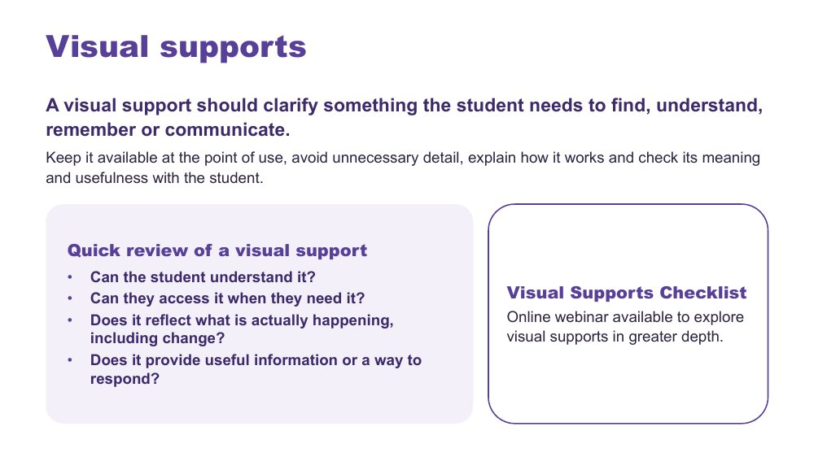 | Visual supports  SUGGESTED TIME  3 min  MINUTES INTO SESSION  23 - 26  PARTICIPANT GUIDE  Participant Guide - Quick review of a visual support

Option 4 of 4: visual supports that clarify what students need to find, understand, remember or communicate.
WHAT TO DO  - Keep this input to about three minutes.  - Start with what information students need, not with a particular visual tool.  - Note that a support is not automatically accessible because it is visual: check students understand what it represents and can use it.  - In secondary, visual supports can look like written instructions that stay on the board or class page, task maps, checklists and assessment calendars. Check they are respectful and suit the student's age.  - For students who use AAC, ask how information is made accessible and how they can respond; keep their communication system available in every class, during transitions and changes.  - Use the four quick-review questions on the slide to review an example briefly.  - Ask the producer to paste details of the Visual Supports Checklist and the webinar into the chat once confirmed. | KEY MESSAGES  - A visual support is useful only when it improves access for the intended student or group.  - Visual supports should support access, communication and agency, not simply compliance.  - Start with what the student needs to know and how they can respond, rather than which visual you want to use.

YOU MIGHT SAY
We're introducing some key principles around visual supports here, but this is a much bigger area than we can cover in this part of the session. You'll have access to a Visual Supports Checklist to help you think through supports in your own setting. There is also an online webinar that explores visual supports in greater depth if you'd like to extend your learning.
What information does the student need here, and how can they respond?

KEEP IN MIND
- Avoid prescribing one format for all Autistic students.
- Some young people will avoid a support that marks them out in front of peers. Designing it for the whole class can help.
- Do not assume access to AAC means spoken instructions, schedules or changes are automatically understood.
- Do not read the absence of a spoken response as absence of understanding, preference, opinion or a response.

Background Examples of visual supports include photographs, symbols, written words, checklists, maps, task maps, choice supports, visual schedules and assessment calendars. Visual information can sit alongside spoken communication rather than replacing it. The checklist prompts: Purpose, Meaning, Access, The real day, Communication and agency, Review. Its closing question: Does this support give this student useful information they can understand, access and act on?
Thread Links back to receptive and expressive communication from Online Session 2.
RESOURCES
- Visual Supports Checklist - link to confirm
- Online webinar on visual supports - link to confirm

SESSION 3 | Designing for Access Across Secondary School | SLIDE 10 of 17

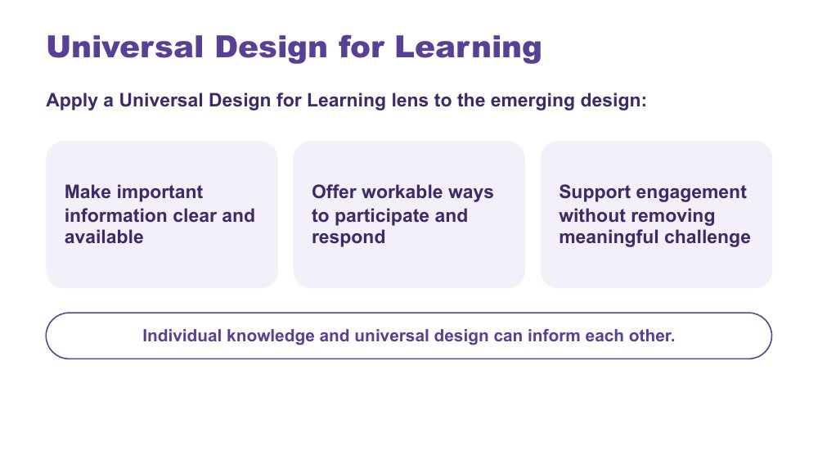 | Universal Design for Learning  SUGGESTED TIME  1 min  MINUTES INTO SESSION  26 - 27

Frame a Universal Design for Learning lens before each person's accessibility check.
WHAT TO DO  - Keep this input to about one minute.  - Introduce Universal Design for Learning using the three points on the slide.  - Invite one quick example in the chat for any of the points, for example more than one way to show learning in an assessment task.  - Name that individual knowledge and universal design can inform each other. | KEY MESSAGES  - Universal design and individual knowledge can inform each other.  - The presence of a resource does not guarantee access.

SESSION 3 | Designing for Access Across Secondary School | SLIDE 11 of 17

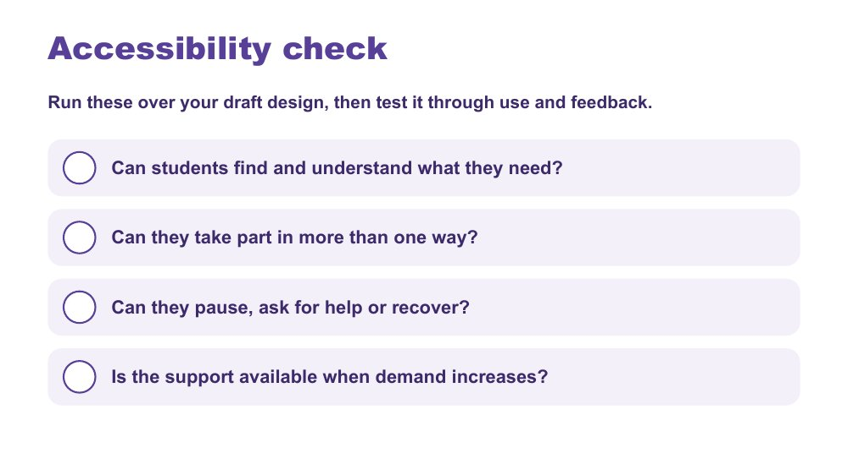 | Accessibility check  SUGGESTED TIME  4 min  MINUTES INTO SESSION  27 - 31  GROUPING  On your own  PARTICIPANT GUIDE  Participant Guide - Accessibility check

Each person tests their draft design against four accessibility questions.
WHAT TO DO  - Ask participants to choose one or two options from the menu, tick them in Options I chose in the Participant Guide, and add them to their brief as a draft design.  - Ask them to run the four questions over their draft design and tick each in the Participant Guide.  - Where the answer is "not yet", ask them to adjust the design before moving on.  - Ask whether participation, help, pause and recovery are available in more than one way, and whether that holds with a different teacher or on a relief day.  - Offer a reaction (for example a thumbs up) when people are ready to move on. | KEY MESSAGES  - Accessibility is tested through use and feedback, not assumed from the presence of a resource.

ACTIVITY | Individual check in the Participant Guide on your own · about 4 minutes
Run these over your draft design, then test it through use and feedback.
- Can students find and understand what they need?
- Can they take part in more than one way?
- Can they pause, ask for help or recover?
- Is the support available when demand increases?
- Where the answer is "not yet", adjust the design.

SESSION 3 | Designing for Access Across Secondary School | SLIDE 12 of 17

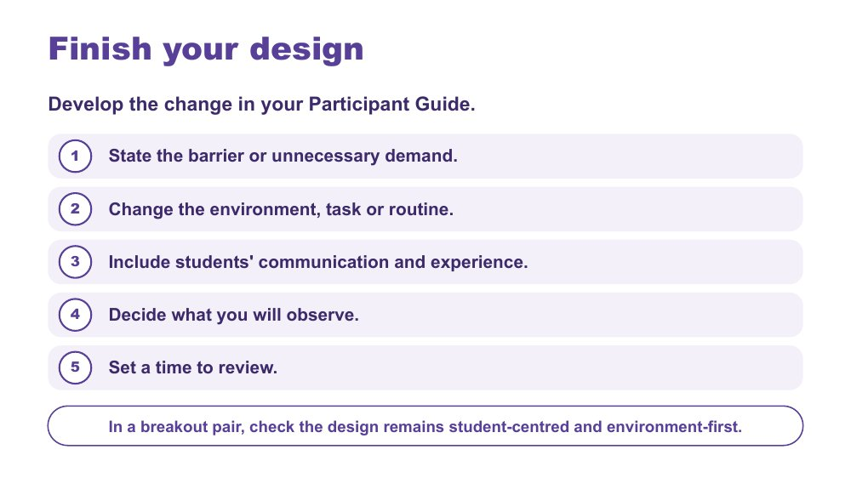 | Finish your design  SUGGESTED TIME  12 min  MINUTES INTO SESSION  31 - 43  GROUPING  On your own, then breakout pairs  PARTICIPANT GUIDE  Participant Guide - My design

Each person develops one practical change to their lesson, assessment task or handover, ready to try and review, then checks it with a breakout partner.
WHAT TO DO  - Ask the producer to paste the five steps and the pair-check question into the chat before breakouts open.  - Give about seven minutes for each person to work through the five steps in the Participant Guide.  - Ask them to name the barrier or demand before choosing a strategy, and to keep the change small: something a teacher could try this week is a good size.  - For a handover or assessment task, ask who else needs to know: other subject teachers, relief teachers, learning support, the year level coordinator.  - Producer opens breakout pairs for about five minutes: each person has two minutes to explain their change and hear one question back. Send a one-minute warning.  - Remind pairs to use initials or roles only. Breakout rooms are not recorded.  - Main-room alternative: stay together and invite a three-part chat check (change, who needs to know, review); read one or two and invite refinements without identifying the context. | KEY MESSAGES  - The measure of success should be access, not compliance.  - The change should be specific, workable and reviewable.

ACTIVITY | Individual design in the Participant Guide, with a breakout-pair check on your own, then breakout pairs · 12 minutes (about 7 minutes design, 5 minutes pair check)
Develop the change in your Participant Guide.
- State the barrier or unnecessary demand.
- Change the environment, task or routine.
- Include students' communication and experience.
- Decide what you will observe.
- Set a time to review.
- In a breakout pair, check the design remains student-centred and environment-first.
Bring the room back
- Does the change respond to the barrier you named?
- Will it hold across subjects, teachers and relief days?
Close: Keep a one-sentence description of the change and the access question it addresses.

KEEP IN MIND
- Avoid making students' compliance the success measure.
- Some people will prefer not to go to a breakout. Let them stay in the main room with the chat option.

Background Small, free changes might be instructions written as well as spoken, a two-minute warning before packing up, or showing the finished exemplar first. Some changes need a decision beyond one classroom, such as assessment policy or timetabling. Ask participants to note these; they come back in the commit at the end of the session.

SESSION 3 | Designing for Access Across Secondary School | SLIDE 13 of 17

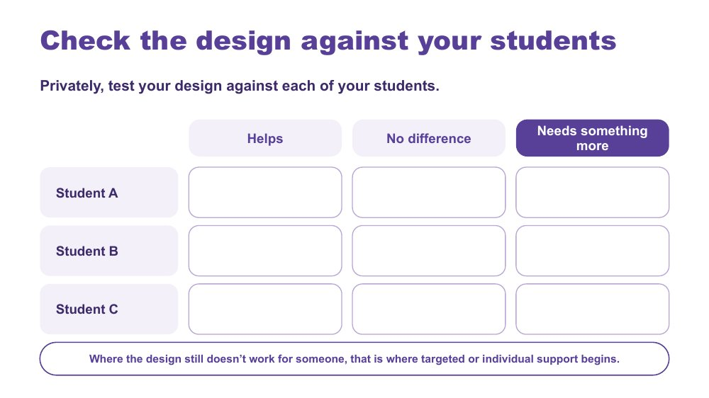 | Check the design against your students  SUGGESTED TIME  5 min  MINUTES INTO SESSION  43 - 48  GROUPING  On your own  PARTICIPANT GUIDE  Participant Guide - My students check

Each person privately tests their design against each of the students they have in mind.
WHAT TO DO  - Welcome people back from breakouts.  - Ask each person to use the My students check in their Participant Guide, privately.  - Ask them to mark each student (Student A, B, C) as Helps, No difference or Needs something more.  - Name that across the group there are many real students being checked against these designs: this is where the broad, mixed picture of autism shows up.  - Invite people to share in the chat only what they choose, for example how many "needs something more" marks their design collected, without describing students.  - Invite one or two examples of "needs something more" to open the continuum discussion. | KEY MESSAGES  - Where the design still doesn't work for someone, that is where targeted or individual support begins.  - The same design will work differently for different Autistic students.

ACTIVITY | Private check in the Participant Guide on your own · 5 minutes
Privately, test your design against each of your students.
- List your students as Student A, B and C.
- Mark each: Helps, No difference or Needs something more.
- Share in the chat only what you choose.
Bring the room back
- How many "needs something more" marks did your design collect?
Close: Where it helps, the universal design is doing its job. Where it makes no difference or a student needs something more, that leads into the continuum of support.

KEEP IN MIND
- Keep it private: no names or identifying details, initials or letters only.
- A student who seems fine may be masking. "No difference" is worth a second look.

Background This keeps individual students in view without building a profile of one young person.
Thread Leads straight into the continuum of support.

SESSION 3 | Designing for Access Across Secondary School | SLIDE 14 of 17

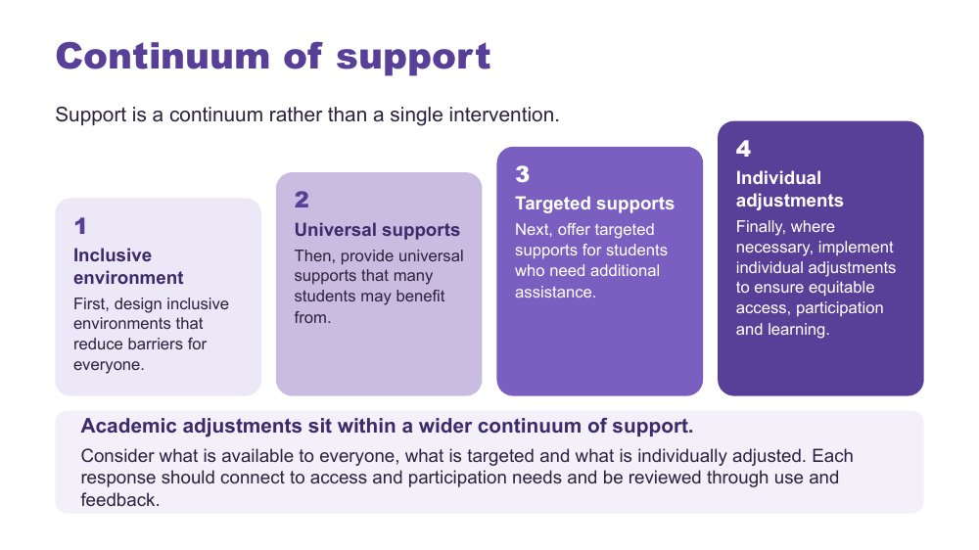 | Continuum of support  SUGGESTED TIME  4 min  MINUTES INTO SESSION  48 - 52

Show what happens when the check shows "needs something more": a continuum from inclusive environment to individual adjustments.
WHAT TO DO  - Open from the "needs something more" examples just shared in the chat.  - Walk the four layers: inclusive environment, universal supports, targeted supports, individual adjustments.  - Use one example per layer from the background below.  - Explain the order: design for everyone first, then add targeted and individual support where it is needed.  - Connect adjustments to evidence from the secondary day map, consultation and the design process. | KEY MESSAGES  - Support is a continuum rather than a single intervention.  - Academic adjustments respond to access and participation needs.  - Each response should connect to access and participation needs and be reviewed through use and feedback.

KEEP IN MIND
- Do not imply that diagnosis alone determines an adjustment.

Background Inclusive environment: predictable routines across classes, clear expectations, assessment schedules published early, and a school culture where different ways of participating are accepted and valued. Universal supports: instructions in verbal, written and visual forms, flexible ways to demonstrate learning, exemplars, a class page where tasks stay available. Targeted supports: a small group receives pre-teaching of key vocabulary, a structured organisation checklist or check-ins on assessment milestones. Individual adjustments: a personalised adjustment plan, for example a quieter space for assessments, additional processing time, a task broken into visible steps and alternative ways to demonstrate learning.

SESSION 3 | Designing for Access Across Secondary School | SLIDE 15 of 17

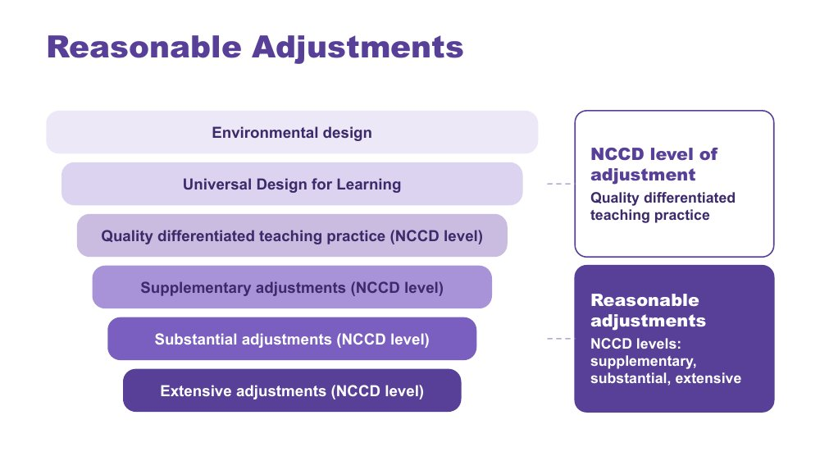 | Reasonable Adjustments  SUGGESTED TIME  2 min  MINUTES INTO SESSION  52 - 54

Place reasonable adjustments and NCCD levels of adjustment within the layers of inclusive design.
WHAT TO DO  - Walk the funnel from environmental design and UDL through quality differentiated teaching practice (an NCCD level of adjustment) to supplementary, substantial and extensive adjustments (the other three NCCD levels of adjustment).  - Give the definition of reasonable adjustments below.  - Distinguish reasonable adjustments (the support actions) from the NCCD (the process for collecting information about them). | KEY MESSAGES  - Adjustments are individualised, strengths based, remove barriers, practical and effective, based on informed decision making, and empowering and enabling.  - Supports and adjustments build student capability, confidence, self-advocacy and independence, not dependence on adults.

YOU MIGHT SAY
Reasonable adjustments are changes or supports that help students access and participate in education in a way that works for them.

KEEP IN MIND
- Do not give legal advice or present the session as a substitute for school or system processes.

Background Adjustments align to the curriculum. Schools consider the needs of the student as well as the impact on staff, other students and available resources. A student is included in the NCCD when they have a disability as defined under the Disability Discrimination Act (DDA), the school has provided reasonable adjustments to address their educational needs, and evidence exists that the adjustments have been provided and monitored. The NCCD helps schools demonstrate compliance with the DSE, monitor the effectiveness of adjustments, ensure students receive appropriate support, and inform planning and resource allocation.

SESSION 3 | Designing for Access Across Secondary School | SLIDE 16 of 17

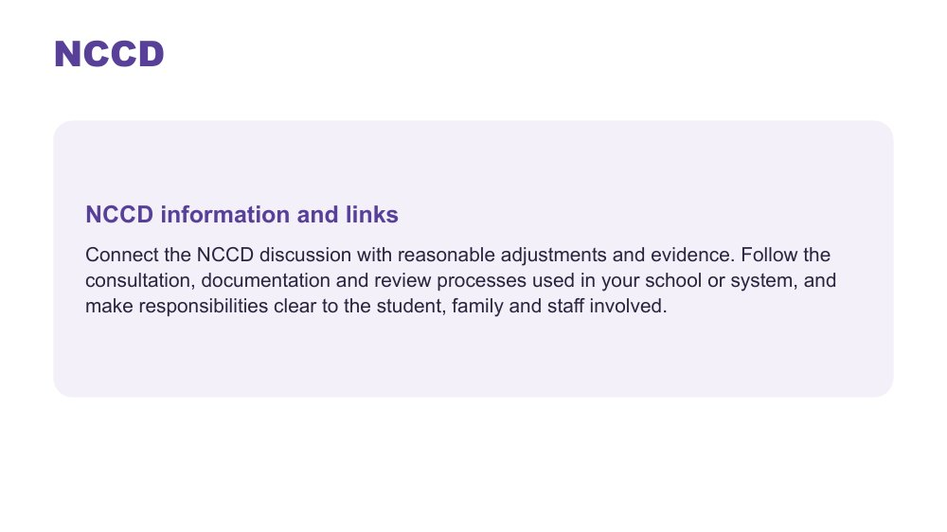 | NCCD  SUGGESTED TIME  2 min  MINUTES INTO SESSION  54 - 56

Direct participants to current official NCCD information and their local processes.
WHAT TO DO  - Ask the producer to paste current official NCCD information into the chat.  - Connect the NCCD discussion with reasonable adjustments and evidence.  - Invite participants to follow the consultation, documentation and review processes used in their school or system.  - Encourage them to make responsibilities clear to the student, family and staff involved.  - Direct local procedural questions to the appropriate school or system contact. | KEY MESSAGES  - Use current official NCCD information.  - Follow school and system requirements for local processes.

KEEP IN MIND
- Do not give legal advice or present the session as a substitute for school or system processes.
- Do not imply that diagnosis alone determines an adjustment.

Thread Consultation is developed further in Online Session 4. The NCCD Meetings Tool Kit is listed in the Participant Guide under Connections that continue.

SESSION 3 | Designing for Access Across Secondary School | SLIDE 17 of 17

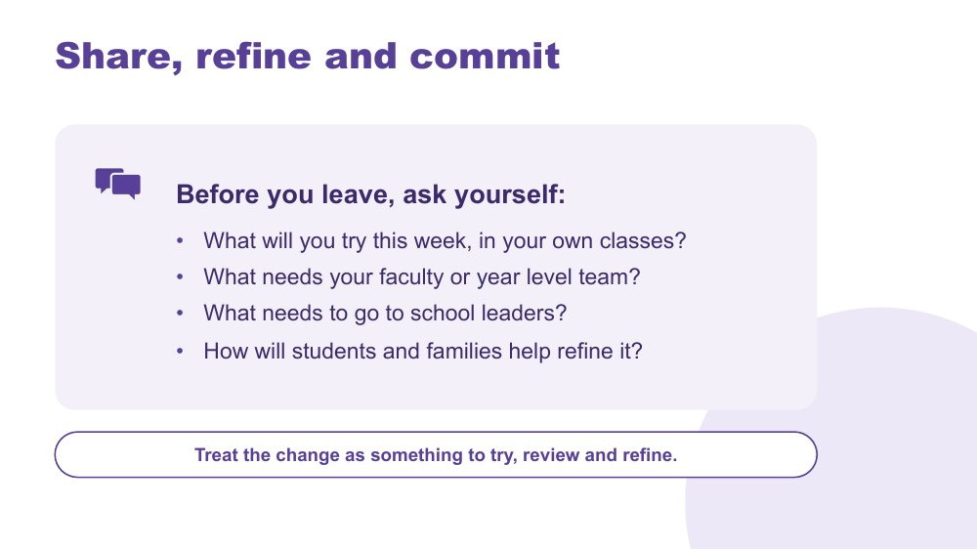 | Share, refine and commit  SUGGESTED TIME  4 min  MINUTES INTO SESSION  56 - 60  GROUPING  On your own  PARTICIPANT GUIDE  Participant Guide - Commit

Refine the design and decide on realistic next steps: in your own classes this week, with your faculty or year level team, and with school leaders.
WHAT TO DO  - Ask the producer to paste the four questions into the chat.  - Ask participants to turn to the Commit section of the Participant Guide and fill in the boxes: This week, in my own classes; With my faculty or year level team; To raise with school leaders; Who I will involve, including the student and family; How students and families will help refine it.  - Explain why there are three levels. Many barriers in secondary, such as assessment policy, timetabling and reporting, sit beyond one classroom. Naming which level a change belongs to is useful, and it does not mean the design has failed.  - Invite optional sharing in the chat (roles only), and read one or two aloud.  - Encourage consultation with students, families and relevant school colleagues rather than presenting the design as finished.  - Preview Online Session 4 on working in partnership, and mention that their "this week" change can become the starting point for the action they plan there. | KEY MESSAGES  - A design change is something to try, review and refine.  - Student and family knowledge can refine what educators notice and try.

ACTIVITY | Personal commitment in the Participant Guide, with optional chat share on your own · about 4 minutes
What will you try this week, in your own classes? What needs your faculty or year level team? What needs to go to school leaders? How will students and families help refine it?
- This week, in my own classes.
- With my faculty or year level team.
- To raise with school leaders.
- Who I will involve, including the student and family.
- How students and families will help refine it.
Close: Treat the change as something to try, review and refine.

KEEP IN MIND
- Keep any public example anonymised.
- Keep commitments within each person's role; a question for consultation is enough if a trial is not appropriate.

Thread Leads into Online Session 4 on partnership, including adolescents in their own meetings.

SESSION  4 | ONLINE · 60 MINUTES · 17 SLIDES  Working in Partnership with Students and Families

SESSION INTENT
Bring student, family, support staff and school knowledge together with the student at the centre, examine how power shapes consultation, and show how adolescents can take part in, and over time lead, their own meetings. Close the series with protected time to plan one change to a lesson, assessment task or handover and one purposeful conversation, connected to belonging, capacity and joy.
PARTICIPANTS LEAVE WITH
- explain why the student sits at the centre of every partnership, with knowledge spread across more people in secondary
- identify where power sits in home-school meetings and one process change the school could make
- use practical ways to consult students and families, including discussing capacity without blame
- describe how adolescents can be prepared to take part in, and over time lead, their own meetings
- name one strategy to start, one to continue and one to reconsider, and plan a real conversation with a family, the student or a colleague who teaches them, within two weeks
- know where continuing learning and community sit beyond the series

RUN SHEET
Minutes in | Segment | Slides | Minutes
0 - 6 | Reconnect: the student at the centre | 1-2 | 6
6 - 20 | Power and student voice | 3-5 | 14
20 - 27 | Consulting well and adolescents in their own meetings | 6-8 | 7
27 - 34 | Capacity without blame and bridge | 9-10 | 7
34 - 51 | Flourishing frame, action plan and conversation plan | 11-13 | 17
51 - 56 | Final reflection and connections | 14-15 | 5
56 - 60 | Feedback and farewell | 16-17 | 4

PREPARE
☐ Adon video cued with captions; share computer sound tested (slide 5).
☐ Shared whiteboard set up with Home, School and Solutions columns; link ready for the chat (slide 4).
☐ Chat text ready to paste: power prompts, action-plan stems and the website link.
☐ Participants reminded to bring their Participant Guide, Session 1 notes and Session 3 commit notes.
☐ Visible timer for the private planning time (slides 10, 12, 13).
☐ Feedback link and QR code confirmed, and the form has an option for the online series; accessible alternative ready.
☐ Webinar, deep dive and Community of Practice access information, if supplied.

Producer cues · Session 4
For the producer or co-host. At the start: admit participants, turn on captions, and paste the Participant Guide link and the session title in the chat. For each activity: paste the prompt before rooms open, broadcast a one-minute warning, and close rooms on time.
Slide | Activity | How | Time | Paste in the chat
4 | Power dynamics activity | individual, whole group in the main room | 6 minutes | Where do power imbalances sit in the home-school relationship, and how could you address them?
10 | Bridge to the next family conversation | on your own | 4 minutes | Prepare for one purposeful conversation.
12 | Start · Continue · Reconsider | on your own | 7 minutes | What matters most now, and what is one change you will take forward?
13 | Plan the next conversation | on your own, optional chat share | 8 minutes | Plan one real conversation you will have within two weeks.

SESSION 4 | Working in Partnership with Students and Families | SLIDE 1 of 17

 | Working in Partnership with Students and Families  SUGGESTED TIME  3 min  MINUTES INTO SESSION  0 - 3

Welcome participants back, reconnect with the Session 3 design work and open the final session on partnership.
WHAT TO DO  - Welcome participants back and restate the participation choices: cameras optional; chat, reactions, speaking, private notes or passing all count. People can step away and come back whenever they need to.  - Reconnect since last session: invite a reaction or a short line in the chat if anyone tried their Session 3 "this week, in my own classes" change. No report needed.  - Name the shift: everything designed in Session 3 was based on what teachers can see and work out for themselves. This session is about hearing from the people who know the student best.  - Pick up the Session 3 close: what needs your faculty or year level team, and how will students and families help refine it?  - Acknowledge that participants may bring both productive and difficult partnership experiences.  - Remind the group that sharing is voluntary and examples stay anonymised: initials or roles only, in the chat and in breakout rooms.  - Let people know this is the last session of the series, and that the second half is protected planning time. | KEY MESSAGES  - Partnership is part of understanding and support, not an additional task after decisions are made.  - The student, family, support staff and school may each hold different parts of the picture.

KEEP IN MIND
- If anyone missed Online Session 3, invite them to think of one small change to a lesson, assessment task or handover as they go. It can be their Start on slide 12 and the focus of their conversation plan on slide 13.
- Flex points if running behind: on slide 3, keep the private think brief; on slide 7, point to the two columns and move on; on slide 11, read the three cards without discussion. Protect the planning time on slides 12 and 13.

Thread Picks up the Session 3 close (Share, refine and commit) and the two or three students participants have kept in mind since Session 1.

SESSION 4 | Working in Partnership with Students and Families | SLIDE 2 of 17

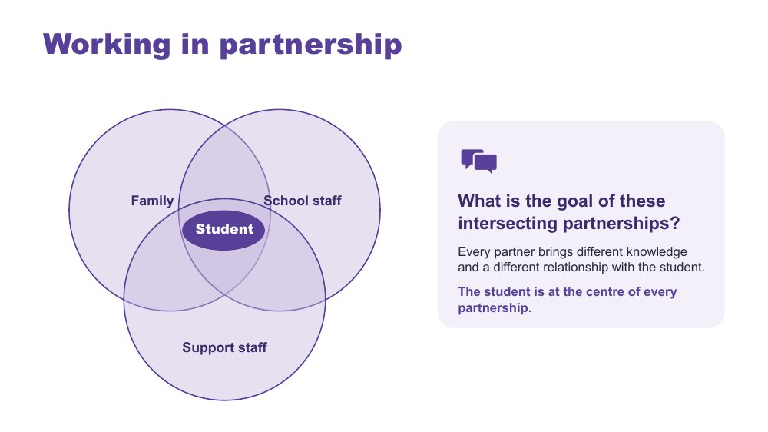 | Working in partnership  SUGGESTED TIME  3 min  MINUTES INTO SESSION  3 - 6  PARTICIPANT GUIDE  Participant Guide - Where partnerships converge

Show where the partnerships around a student intersect, with the student at the centre of every one.
WHAT TO DO  - Introduce the Venn: family, school staff and support staff, with the student at the centre.  - Explain that every partner brings unique knowledge, expertise and perspectives, and a different relationship with the student and with each other.  - Name the secondary picture: there are more people involved. Six or more subject teachers, a year level coordinator, learning support, support staff, and sometimes a relief teacher.  - Ask the question on the slide and invite answers in the chat or out loud: What is the goal of these intersecting partnerships? Read out one or two.  - Steer toward the point that the student is at the centre of all partnerships.  - Acknowledge support staff directly. They often see more of the student across the day than any one teacher, and their knowledge is not always asked for or credited.  - Ask who is missing from the picture and how the student's own communication can be included. | KEY MESSAGES  - Positive partnership keeps the student at the centre.  - No single person holds the complete picture. In secondary it is spread across more people.  - The student knows things no assessment captures: what it feels like, what helps and what is hard.  - The family sees things over time that school may not: how the student is after school, how Sunday nights go, the strategy that worked in primary school.

YOU MIGHT SAY
What is the goal of these intersecting partnerships?

KEEP IN MIND
- Use the elements as discussion prompts rather than a complete definition.

Background Observation only shows a teacher the outside of a student's experience. Asking the student and family fills in more of the picture, and their views are also part of the evidence for NCCD.
Thread Draws on sensory and thinking (Session 1), communication, capacity and masking across the secondary day (Session 2) and the Session 3 design change and continuum of support.

SESSION 4 | Working in Partnership with Students and Families | SLIDE 3 of 17

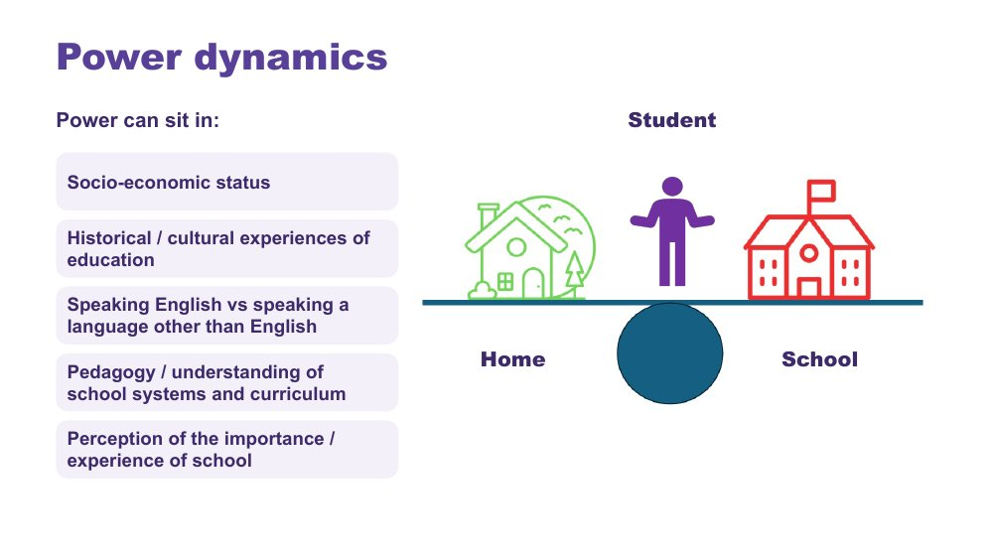 | Power dynamics  SUGGESTED TIME  3 min  MINUTES INTO SESSION  6 - 9

Help participants notice how agendas, language, authority and decision-making shape consultation.
WHAT TO DO  - Introduce the seesaw: school, home and the student.  - Ask participants to think, privately, of their last difficult family meeting. Who chose the room, the time and the agenda? Give a moment before moving on.  - Name where power can sit: socio-economic status, historical and cultural experiences of education, speaking English or another language, understanding of school systems and curriculum, and perceptions of the importance of school.  - Ask the power questions below to examine practice, not to blame individual participants.  - Invite educators to identify where school language, timing or process may create a barrier, including in online or phone meetings. | KEY MESSAGES  - Power is present in meeting structures, language and decision pathways.  - In most school meetings the school chooses the place, the time, the agenda and the language, and the family is often outnumbered.  - By secondary, many families have been to a lot of these meetings. Some arrive worried or on guard because of earlier experiences, at this school or another one.

YOU MIGHT SAY
Who sets the agenda?
Whose knowledge is heard?
Who can make decisions?
Is the student included in a way that works for them?
What could the school change about the process?

KEEP IN MIND
- Avoid describing a family as difficult, disengaged or unrealistic without examining the context and process.
- Some participants will have had genuinely difficult or hostile meetings with families. Acknowledge that partnership works both ways, then come back to what the school can change.

SESSION 4 | Working in Partnership with Students and Families | SLIDE 4 of 17

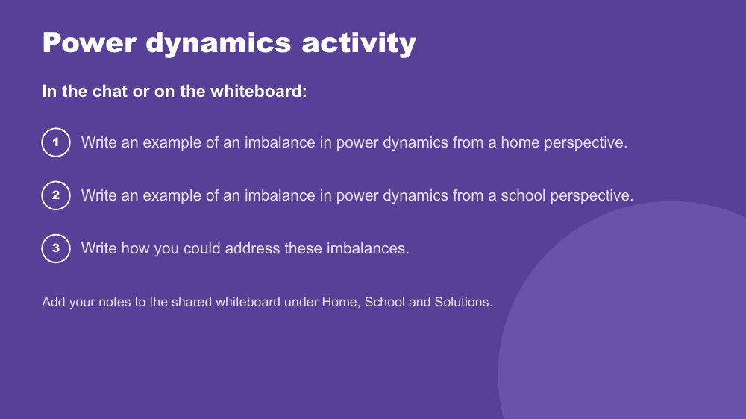 | Power dynamics activity  SUGGESTED TIME  6 min  MINUTES INTO SESSION  9 - 15  GROUPING  Individual, whole group in the main room  PARTICIPANT GUIDE  Participant Guide - Power dynamics

Prompt educators to reflect honestly on perceived and real power imbalances in the home-school relationship.
WHAT TO DO  - Producer: open the shared whiteboard with three columns headed Home, School and Solutions, and paste the link and the three prompts into the chat.  - This is the first time the whiteboard is used: take 30 seconds to show how to open it and add a note. Anyone who would rather not use it can type in the chat instead.  - Direct participants to the three instructions on the slide.  - Offer the options: add notes to the whiteboard, type in the chat, or jot privately in the Participant Guide.  - Support the group to look for solutions rather than place blame.  - In the last minute, read out two or three Solutions notes and ask the debrief question that fits best. | KEY MESSAGES  - Power can be structural, historical, cultural, conscious and unconscious.  - Status can be perceived as an imbalanced power dynamic, regardless of intent.

ACTIVITY | Whiteboard or chat reflection individual, whole group in the main room · 6 minutes
Where do power imbalances sit in the home-school relationship, and how could you address them?
- Write an example of an imbalance in power dynamics from a home perspective.
- Write an example of an imbalance in power dynamics from a school perspective.
- Write how you could address these imbalances.
- Option 1: add your notes to the shared whiteboard under Home, School and Solutions.
- Option 2: type your examples in the chat.
- Option 3: keep your notes private in the Participant Guide.
Bring the room back
- Who sets the agenda?
- Whose knowledge is heard?
- What could the school change about the process?
Close: Ask participants to keep one process change for their conversation plan later in this session.

KEEP IN MIND
- This may be challenging for some participants, who may have found themselves in positions of power or lack of power at different times in their career. Guide individuals to seek solutions and not place blame.
- Whiteboard notes must not identify families, students or staff. Remove anything identifying before the board is saved or shared.

Background Educators are immersed in the culture of education, including a shared understanding of acronyms (e.g. NAPLAN, NCCD, IEP) and secondary systems (subject selection, pathways, senior certificate requirements) which families may not be able to access as easily. Some people will naturally give teachers higher status, which can be a cultural or personal attitude. External providers and professionals can also affect the power dynamic. In secondary, the student sits in the power picture too: adolescents are often discussed in meetings they were not invited to.
Thread The process change chosen here carries into the bridge reflection (slide 10) and the conversation plan (slide 13).

SESSION 4 | Working in Partnership with Students and Families | SLIDE 5 of 17

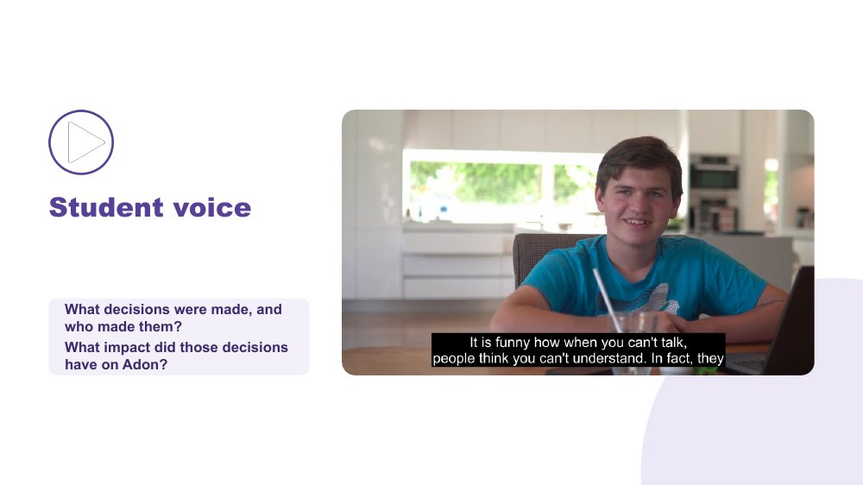 | Student voice  SUGGESTED TIME  5 min  MINUTES INTO SESSION  15 - 20  PARTICIPANT GUIDE  Participant Guide - Student voice

Show what happens when a student is not listened to or consulted.
WHAT TO DO  - Introduce the video as an example of a student who is neither listened to nor consulted.  - Ask participants, while watching, to pay attention to what decisions were made and who made them.  - Share the video with computer sound on and captions visible.  - Ask the group: What impact did those decisions have on Adon? Invite answers in the chat or out loud.  - Connect to the students participants have in mind: how are their preferences asked and heard, and by which of their teachers? | KEY MESSAGES  - Students should have a say in decisions about them, at their level and in a way that works for them.  - Ask students the questions their way: what helps? what's hard? what should teachers know?  - Record their answers in their own words.  - For adolescents, being asked is the starting point. Taking part in their meetings, and over time leading them, comes next (slide 8).

YOU MIGHT SAY
While watching, pay attention to what decisions were made and who made them.
What impact did those decisions have on Adon?

KEEP IN MIND
- Check the video plays smoothly over screen share before the session; have the link ready to paste in the chat as a fallback.

SESSION 4 | Working in Partnership with Students and Families | SLIDE 6 of 17

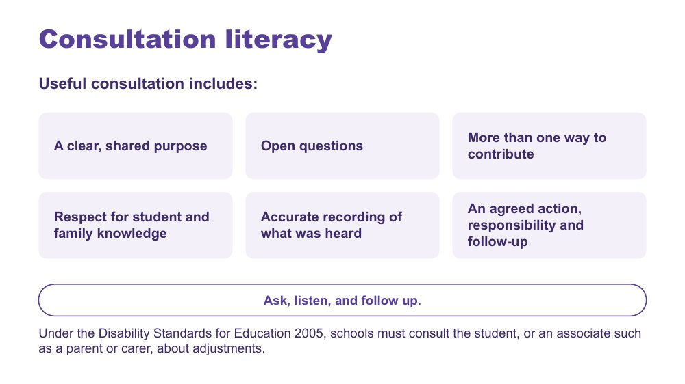 | Consultation literacy  SUGGESTED TIME  2 min  MINUTES INTO SESSION  20 - 22  PARTICIPANT GUIDE  Participant Guide - Consultation checklist

Introduce consultation literacy through asking well, listening and following up.
WHAT TO DO  - Walk through what useful consultation includes.  - Compare two questions: 'Any concerns?' and 'What does a good morning look like?' Ask what each one would bring out; take one or two answers in the chat.  - Point out that following up is easy to skip: tell the family and student what you did with what they told you. It makes them more likely to tell you things next time.  - Read the line at the bottom of the slide: under the Disability Standards for Education 2005, schools must consult the student, or an associate such as a parent or carer, about adjustments.  - Finish with the line on the slide: ask, listen, and follow up. | KEY MESSAGES  - Ask, listen, and follow up.  - Ask specific questions, and ask in the way that suits the person.  - Views that are recorded and acted on are good practice, and they are also evidence.  - Tools should support consultation rather than replace listening and student voice.  - Under the Disability Standards for Education 2005, schools must consult the student, or an associate such as a parent or carer, about adjustments.

SESSION 4 | Working in Partnership with Students and Families | SLIDE 7 of 17

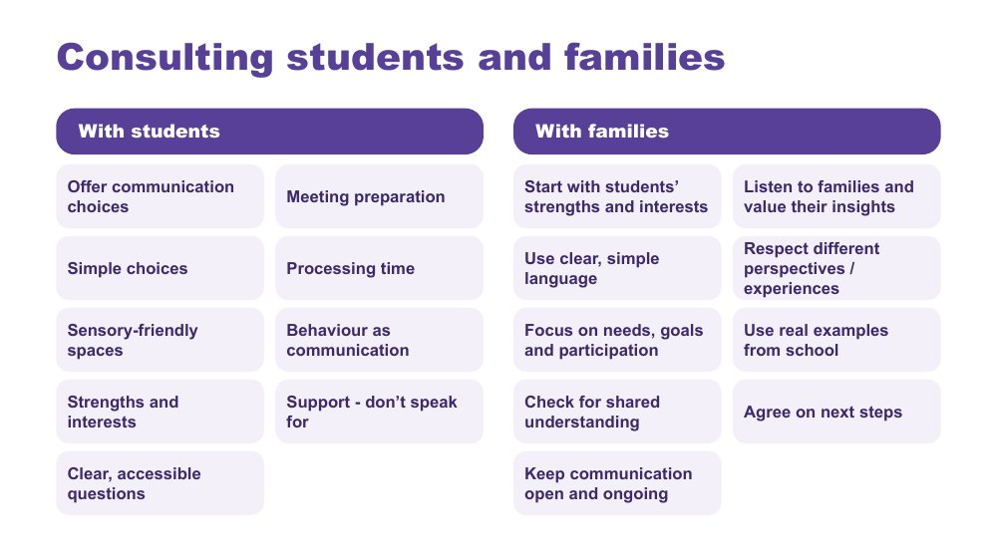 | Consulting students and families  SUGGESTED TIME  2 min  MINUTES INTO SESSION  22 - 24

Give practical ways to consult students and families so every voice can be heard.
WHAT TO DO  - Take the two columns in turn: with students, then with families.  - With students: presume competence, provide communication supports, offer choices, allow time, and act on what students tell us. Adolescents can prepare their own contribution: a written list, a one-page profile, or a trusted adult who supports them to speak rather than speaking for them.  - With families: start with the student's strengths, interests and what works well, and listen to families' knowledge of their young person without making assumptions.  - Ask participants to pick one practice from each column to try with the students they have in mind, and note it privately. | KEY MESSAGES  - Listen, adapt, give choices, and make it easy for every student to have a voice.  - Ensure trusted supporters assist communication without replacing the student's voice.  - Use plain language and explain educational terms clearly.  - Focus on the student's needs and goals, not just their diagnosis.  - Recognise that some parents will be neurodivergent themselves.

Background Student consultation: provide multiple communication options (AAC, visuals, writing, drawing, video, symbols); prepare students in advance with questions, agendas and meeting information; use supported decision-making with simple choices and extra processing time; create sensory-friendly environments; recognise that behaviour is communication and can indicate preferences; build on strengths, interests and preferences; use accessible, strengths-based questions. Family consultation: be respectful of different cultures, experiences and family perspectives; use real examples from school to discuss supports and adjustments; check everyone has the same understanding; agree clear next steps and how progress will be reviewed; keep communication open and ongoing.
Thread Picks up the consultation, documentation and review processes named alongside NCCD in Session 3. Leads into slide 8, adolescents in their own meetings.

SESSION 4 | Working in Partnership with Students and Families | SLIDE 8 of 17

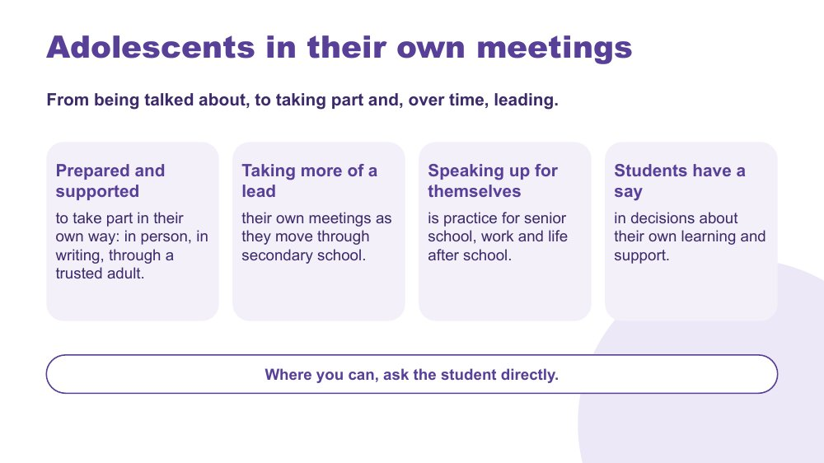 | Adolescents in their own meetings  SUGGESTED TIME  3 min  MINUTES INTO SESSION  24 - 27  PARTICIPANT GUIDE  Participant Guide - Adolescents in their own meetings

Show how, in secondary, students can move from being talked about to taking part in, and over time leading, their own meetings.
WHAT TO DO  - Read the line at the top of the slide: from being talked about, to taking part and, over time, leading.  - Walk through the cards: prepared and supported to take part in their own way (in person, in writing, through a trusted adult); taking more of a lead as they move through secondary school; speaking up for themselves as practice for senior school, work and life after school; having a say in decisions about their own learning and support.  - Give examples of taking part: attending for part of the meeting, a written contribution read aloud, a one-page profile, questions sent in advance, a trusted adult who speaks with them. Joining an online meeting with camera off or through the chat can be another option.  - Link to Session 2: students are more likely to speak up for themselves where they feel safe. A student who masks all day may need a safe setting and some preparation first.  - Finish on the line at the bottom of the slide: where you can, ask the student directly. | KEY MESSAGES  - Adolescents can take part in their own meetings when they are prepared and supported, and can take more of a lead as they move through secondary school.  - Taking part can look different for each student: in person, in writing, or through a trusted adult.  - Speaking up for themselves now is practice for senior school, work and life after school, so teaching it is part of transition planning.

YOU MIGHT SAY
Students have a say in decisions about their own learning and support.
Where you can, ask the student directly.

KEEP IN MIND
- Being in the room without preparation is not real participation. Do not present attendance at a difficult meeting as the goal on its own.
- Avoid treating a student's choice not to attend, or to contribute in writing, as a lack of self-advocacy.

Background In secondary, the question moves from whether the student was asked, to how the student can be prepared to be in the room and to lead where they choose to.
Thread Builds on the Adon video (slide 5) and Session 2 on adolescence and masking; carries into the conversation plan (slide 13), where the student themselves is one of the options.

SESSION 4 | Working in Partnership with Students and Families | SLIDE 9 of 17

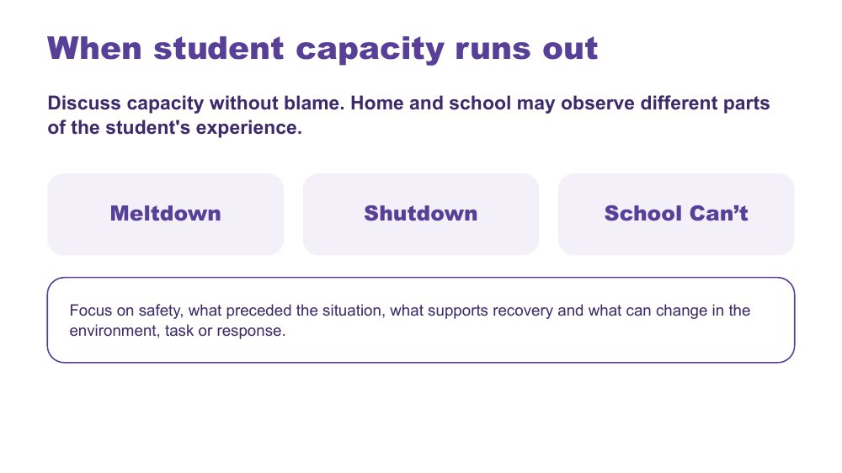 | When student capacity runs out  SUGGESTED TIME  3 min  MINUTES INTO SESSION  27 - 30

Introduce meltdown, shutdown and School Can't within partnership discussion, without blame.
WHAT TO DO  - Let people know this slide touches on distress, and that they can step away or turn off their camera if they need to.  - Introduce the three terms without presenting them as wilful behaviour: a meltdown is an outward response to overwhelm, not a tantrum or a choice; a shutdown is an inward response to overwhelm, quiet and easily missed; School Can't is not truancy or defiance.  - Name the secondary pattern: shutdown in a Year 9 class can look like disengagement or a student who seems 'good and chilled', and School Can't often builds through the secondary years (dreading Sunday nights, partial days).  - Connect back to Session 2: capacity gets used up across a day with six teachers. Ask 'what ran out, and when?' rather than 'how do I stop this?'  - Point to the focus line: safety, what preceded the situation, what supports recovery and what can change in the environment, task or response. | KEY MESSAGES  - Capacity should be discussed without blame.  - Home and school may observe different parts of the student's experience. Families often see how much the student has left at the end of the day; school sees what used it up. Together they give a fuller picture.  - Use non-blaming language and the safety guidance for this series.

KEEP IN MIND
- Do not frame meltdown, shutdown or School Can't as wilful misbehaviour or a failure of parenting.
- Keep the tone informative and calm: no crisis stories or videos of distress, and do not invite personal crisis stories in the chat.
- If people ask for behaviour-management techniques, point them back to Session 3: design and prevention.
- Do not offer clinical, diagnostic, legal or crisis guidance beyond the material.

Background This content sits within partnership, late in the series, on purpose, so the series does not start from distress. When home and school share what they see, they are more likely to notice early that a student is running low on capacity.
Thread Builds on capacity and accumulated demands across the secondary day from Sessions 1 and 2.

SESSION 4 | Working in Partnership with Students and Families | SLIDE 10 of 17

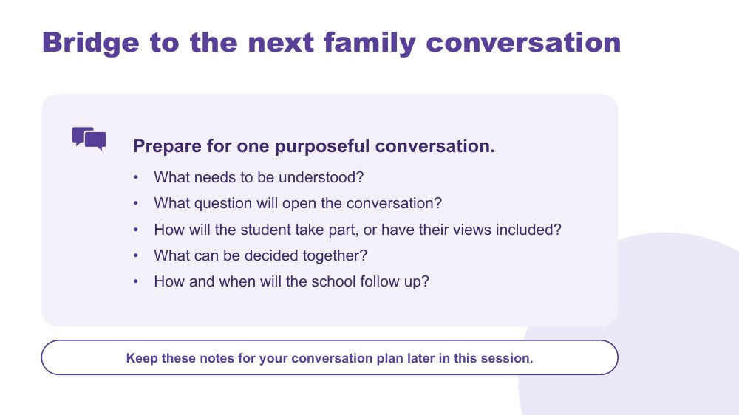 | Bridge to the next family conversation  SUGGESTED TIME  4 min  MINUTES INTO SESSION  30 - 34  GROUPING  On your own  PARTICIPANT GUIDE  Participant Guide - Bridge to the next family conversation

Identify the question and shared purpose participants will take into the conversation plan later in this session.
WHAT TO DO  - Ask participants to return to the students they have in mind and their Session 3 design change (a lesson, an assessment task or a handover).  - Invite them to work through the prompts on the slide privately, in the Participant Guide or their own notes. Cameras can go off.  - Keep the focus on preparation rather than scripting what the family or student should say.  - Ask participants to carry one process change from the power reflection into the plan.  - Ask how the student will take part in the conversation, or have their views included. | KEY MESSAGES  - Prepare for one purposeful conversation.

YOU MIGHT SAY
Keep these notes for your conversation plan later in this session.

ACTIVITY | Private bridge reflection on your own · 4 minutes
Prepare for one purposeful conversation.
- What needs to be understood?
- What question will open the conversation?
- How will the student take part, or have their views included?
- What can be decided together?
- How and when will the school follow up?
Close: Keep these notes open for the conversation plan (slide 13).

Thread Connects to the Session 3 close (Share, refine and commit) and the conversation plan on slide 13.

SESSION 4 | Working in Partnership with Students and Families | SLIDE 11 of 17

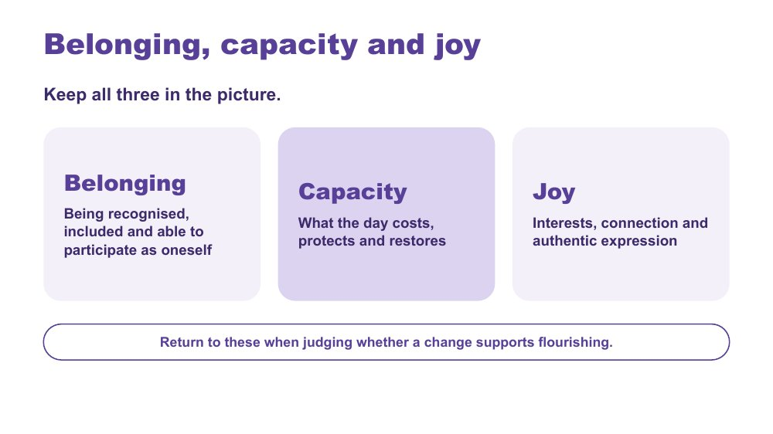 | Belonging, capacity and joy  SUGGESTED TIME  2 min  MINUTES INTO SESSION  34 - 36

Bring together the series lens, learning design and partnership through belonging, capacity and joy.
WHAT TO DO  - Present belonging, capacity and joy as one connected picture, not three separate checks.  - Briefly link the series' three practical strands: a neurodiversity-affirming lens that begins with the person; learning design across the secondary day shaped by student experience; positive partnership that brings student, family and school knowledge together.  - Invite participants to notice whether their design change supports belonging or joy as well as reducing a barrier.  - Point to the last line on the slide: return to these three when judging whether a change supports flourishing. | KEY MESSAGES  - Belonging, capacity and joy belong alongside access and participation.  - Learning design and partnership should stay connected to each student's whole experience, across every period and every teacher.

YOU MIGHT SAY
Belonging, capacity and joy run through all three.

KEEP IN MIND
- Avoid presenting grades, attendance, quiet compliance or conventional independence as the only evidence of flourishing. A student who seems 'good and chilled' may be masking.

Thread Capacity picks up Session 2's thinking about what the secondary day costs and what lightens it; the whole frame is the test for the Session 3 design change and this session's partnership planning.

SESSION 4 | Working in Partnership with Students and Families | SLIDE 12 of 17

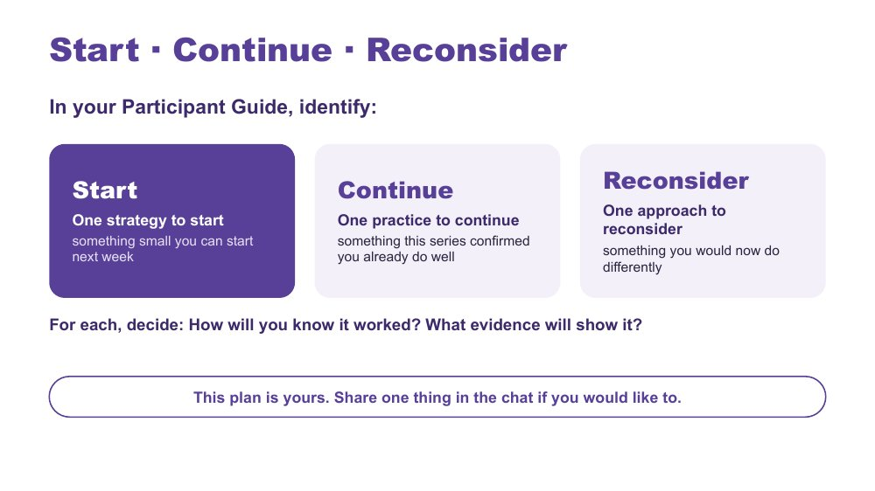 | Start · Continue · Reconsider  SUGGESTED TIME  7 min  MINUTES INTO SESSION  36 - 43  GROUPING  On your own  PARTICIPANT GUIDE  Participant Guide - Start · Continue · Reconsider

Turn the series into one specific, environment-first action for a lesson, assessment task or handover, alongside a practice to keep and one to rethink.
WHAT TO DO  - Ask participants to have their Session 3 commit notes in front of them, especially 'What will you try this week, in your own classes?'  - Ask what matters most now, rather than for a summary of every topic.  - Suggest their Session 3 "this week" change can be their Start. They add how they will know it worked.  - Producer: paste the stems into the chat: I will... / The barrier or demand I am addressing is... / I will notice... / I need to consult... / I will review this on...  - Check that each Start sits within the participant's influence and does not require a student to appear less Autistic.  - Encourage participants to include when they will consult the student, family or team.  - In the last minute, invite anyone who would like to share one thing in the chat. Read out one or two. | KEY MESSAGES  - Use access, participation or experience as the measure, not outward compliance.  - Choose one insight, question or design opportunity specific enough to guide practice and small enough to begin.

ACTIVITY | Individual action planning on your own · 7 minutes
What matters most now, and what is one change you will take forward?
- In your Participant Guide, identify one strategy to start: something small you can start next week. Your Session 3 "this week" change can be your Start.
- Identify one practice to continue: something this series confirmed you already do well.
- Identify one approach to reconsider: something you would now do differently.
- For each, decide: How will you know it worked? What evidence will show it?
- If time allows, note beside your Start the barrier or demand it addresses, who to consult and when to review it.
- This plan is yours. Share one thing in the chat if you would like to.
Close: Ask participants to keep the action small, testable and open to revision.

KEEP IN MIND
- Do not let 'what they will notice' become outward compliance.
- The plan is theirs: sharing in the chat is optional.
- Keep 'reconsider' free of blame: it is about what they would change in light of what they know now.

Thread Picks up the Session 3 close (What will you try this week, in your own classes?).

SESSION 4 | Working in Partnership with Students and Families | SLIDE 13 of 17

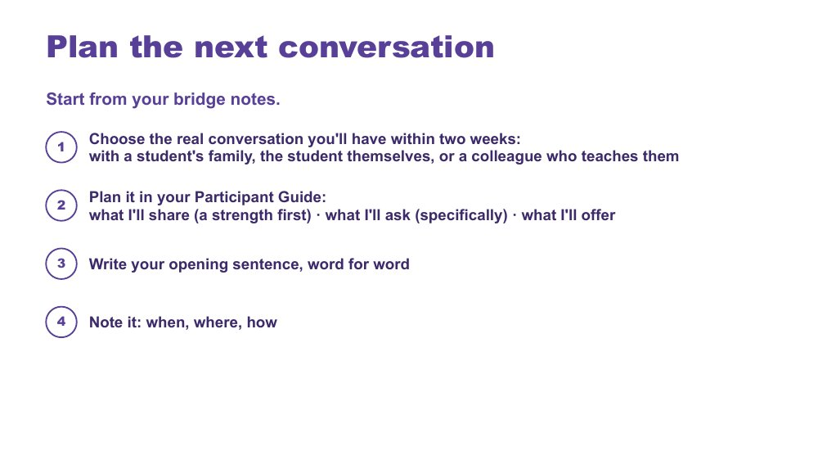 | Plan the next conversation  SUGGESTED TIME  8 min  MINUTES INTO SESSION  43 - 51  GROUPING  On your own, optional chat share  PARTICIPANT GUIDE  Participant Guide - Plan the next conversation

Prepare one purposeful, power-aware conversation within two weeks: with a student's family, the student themselves, or a colleague who teaches them.
WHAT TO DO
- Ask participants to open their bridge notes from slide 10.
- Name the three options: a student's family, the student themselves, or a handover conversation with a colleague who teaches them. Keeping things consistent across six or more teachers is part of partnership too.
- Encourage people towards the family or student option where they can. A conversation with a colleague is often the easier choice.
- Ask them to define the purpose before writing questions or next steps.
- For a handover conversation, use the Session 3 question from Supports that travel: what guidance needs to travel across subjects, rooms, staff changes and relief days? Plan how the student's own voice travels too.
- Ask participants to apply the process change they identified during the power-dynamics reflection.
- Keep this as private planning time with a visible timer; cameras can go off. Optional, if time allows: invite people to post their opening sentence in the chat (no names) and read one aloud.
- Keep all notes anonymised (initials or roles only) and sharing voluntary.

ACTIVITY | Individual conversation planning on your own, optional chat share · 8 minutes
Plan one real conversation you will have within two weeks.
- Choose the real conversation you'll have within two weeks: with a student's family, the student themselves, or a colleague who teaches them (a handover conversation).
- Plan it in your Participant Guide: what I'll share (a strength first), what I'll ask (specifically), what I'll offer.
- Write your opening sentence, word for word.
- Note it: when, where, how.
- If time allows: write the purpose in one sentence, plan how the student's communication and preferences will be included, and name one possible next step and how you will follow up.
Close: Invite participants to check that the plan is clear, respectful and genuinely open to family and student knowledge, including in a handover.

KEEP IN MIND
- Avoid scripting the family's or student's response.
- Avoid treating the meeting as a way to secure agreement with a finished school plan.
- A handover conversation should not become a conversation about the student without the student's voice in it.

Thread Starts from the bridge notes (slide 10), the power-dynamics reflection (slide 4) and, for a handover, Session 3 (Supports that travel).

SESSION 4 | Working in Partnership with Students and Families | SLIDE 14 of 17

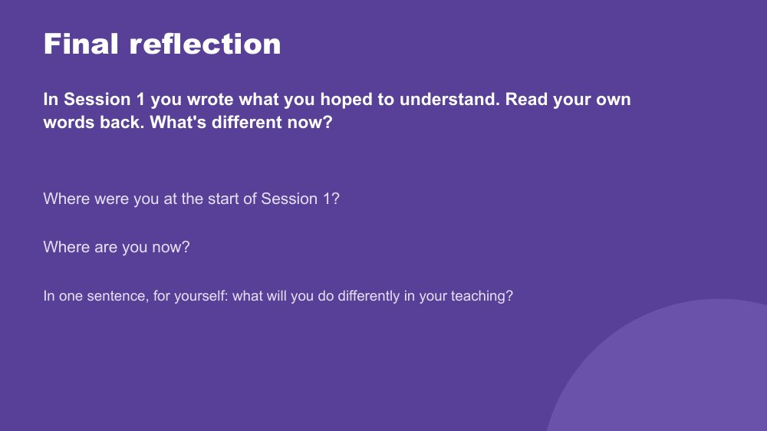 | Final reflection  SUGGESTED TIME  3 min  MINUTES INTO SESSION  51 - 54  PARTICIPANT GUIDE  Participant Guide - Final reflection

Return participants to where they started in Session 1 and name, privately, what has shifted.
WHAT TO DO
- Ask participants to find what they wrote in Session 1 (Think about your students: What are you here for? What would you like to understand better?) and read their own words back.
- Ask: What's different now?
- Give quiet time for the two prompts: Where were you at the start of Session 1? Where are you now?
- Some people may feel they have gone backwards because they now see how much they didn't know. Let them know kindly that this is a normal part of learning, and a sign of progress.
- Ask each person to answer the last question in one sentence, to themselves.
- Keep it private; no sharing is needed. Cameras can go off.

YOU MIGHT SAY
In one sentence, for yourself: what will you do differently in your teaching?

KEEP IN MIND
- Some people will not have their Session 1 notes. Invite them to think back to what they hoped to understand at the start.

Thread Returns to the Session 1 private reflection (Participant Guide - Think about your students).

SESSION 4 | Working in Partnership with Students and Families | SLIDE 15 of 17

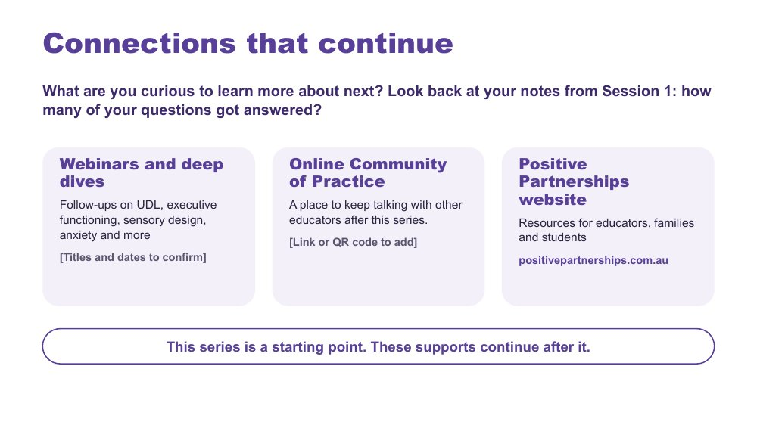 | Connections that continue  SUGGESTED TIME  2 min  MINUTES INTO SESSION  54 - 56  PARTICIPANT GUIDE  Participant Guide - Connections that continue

Introduce continuing professional learning and community pathways.
WHAT TO DO  - Ask: What are you curious to learn more about next? Invite a word or two in the chat.  - Point participants back to their Session 1 notes: how many of their questions got answered?  - Explain how to access each pathway: webinars and deep dives, the Online Community of Practice and the Positive Partnerships website.  - Producer: paste the website and any confirmed links into the chat.  - Keep this brief and practical. | KEY MESSAGES  - The series is one point in continuing professional learning, reflection and partnership.  - Choose the pathway that fits your next question.

YOU MIGHT SAY
This is a starting point. These supports continue after the series.

RESOURCES
- Positive Partnerships website - positivepartnerships.com.au

SESSION 4 | Working in Partnership with Students and Families | SLIDE 16 of 17

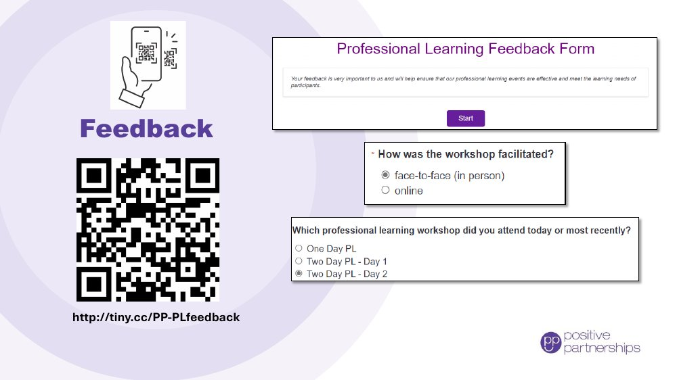 | Feedback  SUGGESTED TIME  3 min  MINUTES INTO SESSION  56 - 59

Collect participant feedback on the online series.
WHAT TO DO
- Explain why feedback is being collected and how it is used.
- Producer: paste the feedback link into the chat; the QR code stays on screen for anyone using a phone.
- Allow protected time for completion before the session ends.
- Let people know they can ask for help in the chat if the form does not open.
- Provide an accessible alternative if the process includes one.

KEEP IN MIND
- Before running the session, confirm the feedback form has an option for the online series.

RESOURCES
- Feedback form - http://tiny.cc/PP-PLfeedback

SESSION 4 | Working in Partnership with Students and Families | SLIDE 17 of 17

 | Good luck on your journey  SUGGESTED TIME  1 min  MINUTES INTO SESSION  59 - 60

Close the series warmly and return participants to student-centred curiosity.
WHAT TO DO  - Thank participants for their attention, questions and professional reflection across the four sessions.  - Invite them to stay curious and keep students at the centre.  - Remind participants to keep their Start · Continue · Reconsider plan and conversation plan.  - State the relevant follow-up and contact arrangements, and leave the room open for a minute for anyone who wants to stay. | KEY MESSAGES  - Stay curious.  - Keep students at the centre.  - Small, informed changes can be reviewed and refined in partnership.

References
Sources named in the slide notes. Background reading for facilitators; participants do not need these.
American Speech-Language-Hearing Association (n.d.). Augmentative and alternative communication [Practice Portal]. asha.org/practice-portal
Brady, N. C., et al. (2016). Communication services and supports for individuals with severe disabilities: Guidance for assessment and intervention. American Journal on Intellectual and Developmental Disabilities, 121(2), 121-138.
Cooper, K., Smith, L. G. E., and Russell, A. (2017). Social identity, self-esteem, and mental health in autism. European Journal of Social Psychology, 47(7), 844-854.
Corden, K., Brewer, R., and Cage, E. (2021). Personal identity after an autism diagnosis: Relationships with self-esteem, mental wellbeing, and diagnostic timing. Frontiers in Psychology, 12, 699335.
Disability Discrimination Act 1992 (Cth).
Disability Standards for Education 2005 (Cth). education.gov.au/disability-standards-education-2005
Human, E. (2015). Tendril theory [comic]. eisforerin.com/2015/08/10/tendril-theory
Hutchins, T. L., et al. (2024). Autism and Developmental Language Impairments. https://doi.org/10.1177/23969415241249944
Milton, D. E. M. (2012). On the ontological status of autism: The double empathy problem. Disability and Society, 27(6), 883-887.
Murray, D., Lesser, M., and Lawson, W. (2005). Attention, monotropism and the diagnostic criteria for autism. Autism, 9(2), 139-156.

